

SAP Business One Implementation

Business Blueprint Documentation For
HMMP Limited

Version: 2.2
Date: 13/01/2016

Revision History

Ver. # | Date | Prepared By | Significant Changes | Reviewed By
1.0 | 7/10/2015 | Yvaine Kong | Initial URS Document | Nick Tapang
1.1 | 23/10/2015 | Yvaine Kong | Blueprint review with users  Pg 12: Credit limit, payment term  Pg 13: Decimal places  Pg 17: Revenue account  Pg 23: Tax group, payment term  Pg 24: Document numbering  Pg 25: Asset group  Pg 27: Customized financial report  Pg 35: Sales G/L account will no longer be specific to insurance company  Pg 36: Sales Accrual  Pg 44, 45: HMDC invoice creation  Pg 45: YOT revenue account  Pg 46, 47: HMMPD invoice creation  Pg 54: Customer master data | Users
1.2 | 2/11/2015 | Yvaine Kong | Interface
1.3 | 5/11/2015 | Yvaine Kong | Users’ review | Ally & Olive
1.4 | 9/11/2015 | Yvaine Kong | Fine tune
1.4-2.2 | 11/1/2016 | Yvaine Kong | Interface
Table of Content
1. Introduction 6
1.1 Overview 6
1.2 Company Profile 7
1.3 Scope 9
2 System Configuration 10
2.1 Company Details – Basic Initialization 10
2.2 Financial Period 11
2.3 Document Setting 12
2.4 General Setting 13
2.4.1 General Setting – BP (Business Partner) 13
2.4.2 General Setting – Budget 13
2.4.3 General Setting – Display 14
2.4.4 General Setting – Font & Bkgd 15
2.4.5 General Setting – Inventory 15
2.5 User ID 16
3 Financial 16
3.1 Chart of Account Structure 16
3.2 G/L Account Determination 17
3.2.1 G/L Determination Account – Sales Tab 17
3.2.2 G/L Determination Account – Purchase Tab 19
3.2.3 G/L Determination Account – General Tab 20
3.2.4 G/L Determination Account –Inventory Tab 20
3.3 Division (Dimensions) and Cost Centers 23
3.4 Project 24
3.5 Tax Setup 24
3.6 Payment Terms Setup and Payment Details 24
3.7 Document Numbering 24
3.8 Fix asset 26
3.9 Others Finance Functions 26
3.10 Financial Reports 28
4 Banking Module 29
4.1 House bank details 29
4.2 Bank Set-up 32
5 Sales & Purchase Process 36
5.1 HMMPL 36
5.2 HMDC 45
5.3 YOT 46
5.4 HMMPD 47
6 Inventory 54
6.1 Service Items 54
6.2 Inventory Items 54
7 Customer & Vendor Master Data 54
8 Medjetco Interface to SAP 56
8.1 Work Flow 56
8.2 Process Documentation 56
8.3 Master Data 57
8.4 Data Processing 57
8.4.1 Sales Estimate 57
8.4.2 A/R Invoice 57
8.4.3 Cost Estimate 58
8.4.4 A/P Invoice 58
New Requirements 23122015 59
8.5 65
8.6 Configuration file 65
8.6.1 DB Name 65
8.7 Configuration table (UDT) 65
8.7.1 Item Code 65
8.7.2 Estimated sales G/L 65
8.7.3 Reversal of estimates sales G/L 65
8.7.4 AR Estimated cost G/L 66
8.7.5 AR Reversal of estimates cost G/L 66
8.7.6 AP Estimated cost G/L 66
8.7.7 AP Reversal of estimates cost G/L 66
8.7.8 AP code for OUT network 67
8.7.9 AR_Footer 67
8.7.10 Email 67
8.7.11 @AE_OUT_GLAP_NONCAP 67
8.7.12 @AE_OUT_GLAR_NONCAP 67
8.7.13 @AE_TPA_APCODE 67
8.8 Data Mapping 68
8.8.1 Sales Order Details based on “MS007_SO__[last day of the month]” 68
8.8.2 Sales Accrual based on Sales Order Details 68
8.8.3 Estimated sales journal based on Sales Accrual created per company code, incurred month and MBMS 68
**if clinic_code in “Sales Order Details” exist in @AE_TPA, go to “cost accrual” 69
8.8.4 AR Invoice Details based on “MS007_AR__[last day of the month] 69
8.8.5 AR Invoice in SAP based on “AR Invoice Details”, created per company code, incurred month and MBMS 69
8.8.6 Reversal of estimated sales journal in SAP. Retrieve the amount from Sales Accrual using invoice number in “AR Invoice Details”. Journal will be passed per company code, incurred month, and MBMS 69
8.8.7 Purchase Order Details based on “MS002_PO__[last day of the month] 70
8.8.8 Cost Accrual based on Purchase Order Details or Sales Order Details (for clinic code in @AE_TPA_APCODE) 70
8.8.9 Estimated cost journal in SAP based on Purchase Accrual, create on journal per clinic code, incurred month and U_Type 71
8.8.10 AP Invoice Details based on “MS002_AP_[last day of the month] 71
8.8.11 AP Invoice in SAP based on “AP Invoice Details”, created per ap_code, incurred month and U_Type 71
8.8.12 Reversal of estimated cost journal in SAP. Retrieve the amount from Cost Accrual using invoice number. Journal will be passed per clinic code, U_Type and incurred month 72
9 CMSS Interface to SAP 73
9.1 Work Flow 73
9.2 Process Documentation 73
9.3 Master Data 74
9.4 Data Processing 74
9.4.1 HMDC/YOT database 74
9.4.2 HMMPD Database 82
9.5 Configuration file 84
9.5.1 DB Name 84
9.6 Configuration table (UDT) 84
9.6.1 Item Code (@AE_ITEMCODE) 84
9.6.2 Payment method (@AE_PAYMETHOD) 84
9.6.3 Email (config file) 85
9.6.4 Percentage (@AE_PERCENTAGE) 85
9.6.5 Contract Owner (@AE_CONTRACT_OWNER) 85
9.7 Data Mapping HMDC & YOT 85
9.7.1 Invoice Details (@AE_RD001_AR) based on “RD001_HMDC_[last day of the month]” or “RD001_YOT_[last day of the month]” 85
9.7.2 Cash Sales AR Invoice based on @AE_RD001_AR 85
9.7.3 Contract AP Invoice based on @AE_RD001_AR 86
9.7.4 Contract AR Invoice based on @AE_RD001_AR 87
9.7.5 Others cash sales based on @AE_RD001_AR. 87
9.7.6 Others AR Invoice based on @AE_RD001_AR. 88
9.8 Data Mapping HMMPD 89
9.8.1 Invoice Details (@AE_RD001_AR) based on “RD001_[clinic]_[last day of the month]” 89
9.8.2 Contract AR Invoice based on “Invoice Details” @AE_RD001_AR 89
9.8.3 Contract AP Invoice based on “Invoice Details” @AE_RD001_AR 90
Validation check: 91
10 Appendix 92
11 Acknowledgement 96

1. Introduction

Overview

The document is created based on the discussion on at the premises of HMMP Limited in Hong Kong. The discussion is in the presence of End-Users from Finance and IT department (for interface).

The objective of having discussion and documentation is to have clear understanding on the requirements and deliverables items from HMMP Limited and Abeo International Pte Ltd, the project team.

User’s requirements study has been conducted on below dates.

Date | Topics | Attendees
5/10/2015 | Sales, Purchase | Amy Tan, Amy Siu, Yvaine Kong, Ally, Olive
6/10/2015 | Banking, Admnistration | Yvaine Kong, Ally, Olive
7/10/2015 | Interface, customer/supplier/item master data, finance, fix asset | IT, Olive, Ally, Yvaine Kong, Amy Siu
8/10/2015 | HMI and HMMS | Rochelle, Olive, Ally

Company Profile

These are the companies that will be setup by Abeo International Pte Ltd.

Company Name (1) | Health Maintenance Medical Practice Limited
Address  Address Line 1:  Address Line 2:  Address Line 3:  Address Line 4:  Country: Zip Code: | Unit 405, 4/F., Tower 1, Silvercord,  30 Canton Road, Tsim Sha Tsui, Kowloon
Tel:  Fax:  Email:  Website: | 25292132  http://www.hmmp.com.hk/
Business Registration /GST Reg no.

Company Name (2) | Health Maintenance DentalCare Limited
Address  Address Line 1:  Address Line 2:  Address Line 3:  Address Line 4:  Country: Zip Code: | Unit 405, 4/F., Tower 1, Silvercord,  30 Canton Road, Tsim Sha Tsui, Kowloon
Tel:  Fax:  Email:  Website: | 25292132  http://www.hmmp.com.hk/
Business Registration /GST Reg no.

Company Name (3) | YOT Tse Ng Tsui Ha Dental Clinic Limited (YOT)
Address  Address Line 1:  Address Line 2:  Address Line 3:  Address Line 4:  Country: Zip Code: | Unit 405, 4/F., Tower 1, Silvercord,  30 Canton Road, Tsim Sha Tsui, Kowloon
Tel:  Fax:  Email:  Website: | 25292132  http://www.hmmp.com.hk/
Business Registration /GST Reg no.

Company Name (4) | HMMP (Dental) Limited
Address  Address Line 1:  Address Line 2:  Address Line 3:  Address Line 4:  Country: Zip Code: | Unit 405, 4/F., Tower 1, Silvercord,  30 Canton Road, Tsim Sha Tsui, Kowloon
Tel:  Fax:  Email:  Website: | 25292132  http://www.hmmp.com.hk/
Business Registration /GST Reg no.

Company Name (4) | HM Investment Holding Limited
Address  Address Line 1:  Address Line 2:  Address Line 3:  Address Line 4:  Country: Zip Code: | Unit 405, 4/F., Tower 1, Silvercord,  30 Canton Road, Tsim Sha Tsui, Kowloon
Tel:  Fax:  Email:  Website: | 25292132  http://www.hmmp.com.hk/
Business Registration /GST Reg no.

Company Name (4) | Health Maintenance Management Services Limited
Address  Address Line 1:  Address Line 2:  Address Line 3:  Address Line 4:  Country: Zip Code: | Unit 405, 4/F., Tower 1, Silvercord,  30 Canton Road, Tsim Sha Tsui, Kowloon
Tel:  Fax:  Email:  Website: | 25292132  http://www.hmmp.com.hk/
Business Registration /GST Reg no.

Scope
Database to be created by Abeo:
HMMPL, HMDC, YOT, and HMMPD

Database to be created by FHG:
HMI and HMMS

The Modules covered under this implementation as follows:
- Administration
- Financials
- Customized PL with clinics break down
- Customized aging report by customer
- Upload of journal entries with DTW format
- Banking
- Incoming payment created from Medjetco and CMSS file for cash sales
- Cheque printing
- Sales
- Interface with Medjetco and CMSS System
- Purchase
- Interface with Medjetco and CMSS System for reimbursement
- Inventory
- Interface

Change requests as follows:
- Upload of recurring posting template
- Upload of receipt settlement with different unique key combination
- Upload of A/R invoice (Possible to use existing program from Indonesia entity)
- Upload of A/P invoice (Possible to use existing program from Indonesia entity)
- Upload of A/P and goods issue with batch management for HMDC and YOT (CR)
- Aging report by insurance company (transactions level)

System Configuration

Company Details – Basic Initialization

No. | Fields | Setting
1. | Chart of Account (COA) | User Defined Template (Harmonized COA across FHG)  YOT uses separate COA (removed)
2. | Local currency  **It is the operating currency in the system. | HKD
3. | System currency  ** It is the reporting currency. Users have an option to see your financial reports in another currency besides Local currency if it is necessary because in SAP each account is refined in Local, System or Specific Currency. In financial reports, you can only see via Local or System Currency | SGD
4. | Default Account Currency | HKD
Important: Company currency setup cannot be amended or changed anymore if there are transactions posted to the system.

5. | Display credit balance with negative sign.  ** Option cannot be changed once selected. | Yes
6. | Negative amount for all reverse transactions. [Yes/No]  Example: Normal (No)  Reversal → Debit Bank 100  Credit Expenses 100  - Total Debit and Credit Values increased.  Example: Negative (Yes)  Debit Expenses -100  Credit Expenses -100  - Total Debit and Credit Values do not increase. | No
  Debit Expenses 100
  Credit Bank 100
7. | What is the default valuation (costing) method you prefer?  The available valuation methods are:  - Moving Average: Calculate the inventory value by the item cost. By selecting this option, the item cost is updated dynamically by every inventory receipt posting.  - Standard Price: Calculate the inventory value by a fixed price. The item’s standard price should be set before you start working in your company.  ** A variance account required: - In certain scenarios, if there are differences between the standard price and the actual price in the purchasing documents, these differences are recorded in the variance account.  - FIFO: Calculates the inventory value by the first in first out method.  - Each inventory receipt transaction creates a “layer” of quantities linked to cost.  - Each inventory release transaction uses quantities and their corresponding costs from the first open layers. | Use FIFO by warehouse and batch
8. | Manage Item Cost as per warehouses?  [Yes] - Different warehouse can have different item cost.  [No] - One item cost for all warehouse. | Yes and by batch  HMDC and YOT have one warehouse each.
9. | Allow stock to be released without Item Cost. | Yes

Financial Period

Queries | Setting
What is the financial period of your company? | from : January 1  To: December 31
Number of Periods in one Financial Year  1 (year), 4 (quarters), 12 (months) | 12 months
Fiscal to be configure in SAP for initial setting: | 2012, 2013 and 2014

Document Setting

No. | Field | Customer Choice
1 | Calculate Gross Profit (%)  - Profit / Sales Price  - Profit / Base Price (Item Cost)  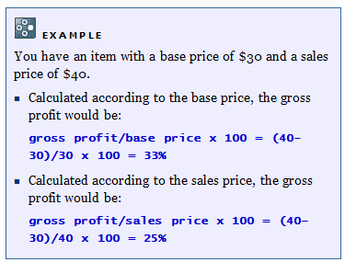 | Profit / Sales Price
2 | Manage Inventory by Warehouse  - If Yes, does not take the stock from another warehouse when the main warehouse does not have inventory.  - If No, takes stock from any available warehouse that has stock | Yes
3 | Block Negative Inventory  - [Yes] Do not allow release of item if stock level is 0.  - [No] Allow release of item if stock level is 0.  Recommended Answer = Yes. It's better to keep the correct stock level in the system and if it is FIFO. | Yes
4 | Response to Release of Inventory below the minimum level  - Without warning  - Warning only  - Block Release | Block Release
5 | Rounding Method  -By Document  When rounding occurs due to exchange rate conversions, put the rounding amount to the Discount field.  -By Currency  When rounding occurs due to exchange rate conversions, put the rounding amount to the Rounding field. | By Currency
6 | Use Warehouse Address  - [Yes] It will take Warehouse address during PO  - [No] It will take Company address during PO | No
7 | Manage Freight in Documents  - [Yes] User can enter freight charge when create AR/ AP  - [No] User cannot enter freight charge when create AR/AP | N/A at the moment
8 | Block documents with earlier Posting Date  - [Yes] User can post a JE with earlier posting date  In each user authorization, you may decide to allow if this user is allowed or disallowed to submit documents with earlier posting date. | No
9 | Allow Future Posting Date  - [Yes] User can post a JE with later posting date  In each user authorization, you may decide to allow if this user is allowed or disallowed to submit documents with later posting date. | Yes

- This is the recommended setting for user environment. If there is any change, users can amend the setting according to their need.

General Setting

General Setting – BP (Business Partner)

** You can change this setting at any time.

Seq. | Queries | Customer Choice
 | Is it a requirement to setup credit limit for your customers?  If yes, where do you want to check the Credit Limit?  AR Invoice | Sales Order | Pick list | Yes at A/R invoice, default set to 9,999,999 for all customers first. Warning only
2. | Default Payment Term for Customer  - When creating new Customer, it will take this default Customer Choice | Net 30 days from document date  (invoice date will be same and put as posting and document date)
3. | Default Payment Term for Vendor  - When creating new Vendor, it will take this default Customer Choice | Net 60 days from posting date (invoice date put in document date and creation date put in posting date)
4. | Activate Approval Procedures function. | Not required
5. | Display Customer Balances by grouping against their Control Accounts? | Yes.

General Setting – Budget

** You can change this setting at any time.

Seq. | Queries | Customer Choice
1. | Is it a requirement to setup Budget for your company?  Annual or monthly budget? | Yes, budget amount to be define by each entity
2. | Where should the budget checking be set?  Purchase Orders | Goods Receipt POs | Accounting | Accounting
3. | Alerts that is needed if over budget? | Yes

General Setting – Display

Seq. | Queries | Customer Choice
 | What would the default Customer Choice for:  - Language  - Color  - Length UoM  - Weight UoM  - Time Format [12H, 24H]  - Date Format  - Separator | - English (UK)  - SAP Signature Design  - Meter  - KG  - 24 H  - Dd/mm/yyyy  - /
 | Decimal places (0…6)  - Amounts  - Prices  - Rates  - Quantities  - Percent  - Units  - Separator  - Thousand Separator | - 2  - 2  - 4  - 0  - 2  - 2  - .  - ,
3. | Currency code on the right. | No.
4. | Exchange Rate Posting methods:  Assumed the local currency is SGD dollar and the foreign currency is the US dollar.  (a). Direct (multiplying)  If you choose the Direct option, then on the Exchange rates table, you would enter  1.2465 as today‘s rate for the US dollar rate.  Example : 1.00 USD = 1.2462 SGD  (b). Indirect (dividing)  If you choose the Indirect option, then on the Exchange rates table, you would enter 0.8024 as today‘s rate for the US dollar rate.  Example : 1 SGD = 0.8024 USD | Indirect  1 HKD = 0.2 SGD

General Setting – Font & Bkgd

Seq. | Queries | Customer Choice
 | Font type and size | Font Type : Arial  Font Size : 12
 | Background image to be display and how.  Image display :  Centralize / Full screen / Tile | Without background.

General Setting – Inventory

Seq. | Queries | Customer Choice
 | Manage item by serial no. or batches? | Yes, some items are managed by batch for HMDC and YOT
 | How to manage?  - On Every Transaction – you are required to assign serial / batch numbers for every inventory transaction.  - On Release Only – you are required to assign serial or batch numbers for inventory release transactions only. | Every transaction
3. | Serial No. will be unique by.  - None  - Mrf. Serial No.  - Serial Number  - Lot Number | NA
4. | Automatically create Equipment Service Card? | No
6. | Default warehouses for all the items | Yes
7. | G/L Accounts are set by; | Warehouse level, put into same sales and inventory account
8. | Auto. Add All Warehouses to New Items  - If you choose Yes, for all new items, it will be tagged to the list of all physical and virtual warehouses in the database. You have to remove manually those warehouses that you do not need to use.  - If you choose No, no warehouse will be tagged to the item. You have to tag manually. | Yes

User ID
This window is used to create a new User Name and Password.

    - User ID and License assignments.
User ID | User Name | Pass | Email | License Type | Remarks
Bonnie | Bonnie Ho | 1234 | bonnieho@hmmp.com.hk | Professional
Olive | Olive Yeung | 1234 | oliveyeung@hmmp.com.hk | Professional
Ally | Ally Lau | 1234 | allylau@hmmp.com.hk | Professional
Kaman | Kaman Kan | 1234 | kamankan@hmmp.com.hk | Professional
Wing | Wing Tong | 1234 | wingtong@hmmp.com.hk | Professional | No need to be created in HMI and HMMPL
Tim | Tim Wong | 1234 | timwong@hmmp.com.hk | Professional
Fanny | Fanny Chu | 1234 | fannychu@hmmp.com.hk | Limited Financial | A/P
Maggie | Maggie Tao | 1234 | maggietao@hmmp.com.hk | Limited Logistic | A/R, Banking
Cherry | Cherry Choy | 1234 | cherrychoy@hmmp.com.hk | Limited Logistic | A/R, banking

Financial

Chart of Account Structure

- In SAP B1, the Chart of Accounts is organized by drawers and levels. All drawers are level 1.
- These drawers, which have been defined by SAP and cannot be changed.

Drawer Name  Level 1 | Account Code
100000000000000 | Assets  Balance Sheet  Accounts
200000000000000 | Liabilities
300000000000000 | Capital and Reserves
400000000000000 | Turnover
500000000000000 | Cost of Sales  Profit and Loss
600000000000000 | Operating Costs
700000000000000 | Non-operating income and expenditure
800000000000000 | Taxation and Extraordinary Items

- A maximum of 4 levels can be defined (including the drawer level).


Εξαμπλε Στανδαρδ ΧΟΑ

Level 1
100000000000000 – Assets
Level 2
15000000 -- Current Assets
Level 3
15101000 – Inventory
15101100 – Inventory (Item Group No 1)
Level 4
15101200 – Inventory (Item Group No 2)

Seq. | Query | Customer Choice
1. | How is the structure of the COA, do they have different G/L account for Inventory, Sales, COGS per item group / warehouse? | No
2. | How do you analyze your profit and loss currently?  For example: Item Group / Location / Others? | By Division, Cost Centers
3. | How do you want to allocate the cost / revenue?  The allocation will be setup in G/L Account Determination.  (a) Warehouse  (b) Item Group | GL determination is at Item Code based on revenue type

G/L Account Determination
GL Account Determination is used to define default G/L accounts for transactions created in SAP. All the transaction involves item posting, (i.e. AR Invoice) accounting entry will be captured by the system automatically from this setup.

Account determination is for non-stock and is defined at Item Code level.
For eg: Outpatient – Consultation, Premium Plan

G/L Determination Account – Sales Tab
Field | Description/Activity | Setting
Domestic Accounts Receivable  Foreign Accounts Receivable | Define the Receivables account for domestic and foreign customers. Make sure the account is located in the Assets drawer and defined as a control account. The Receivables account for domestic and foreign can be the same G/L account. | 1-12100-00 – Trade Receivables – Local  1-12200-00 – Trade Receivables - Foreign
Checks Received | Define the default Checks Clearing account the system will use for incoming payments where the payment means is “Check”. The system debits this account in the incoming payment posting and credits the account when you deposit the check. In the incoming payment window you can change the Checks Clearing account manually.  Account: The code will provide in the COA listing. | Default bank account. Only one default bank account for one company/entity. Users required change bank account if required.  For HMDC and YOT, default bank account is set at clinic level only for interface purpose.
Cash On Hand | Define the default Cash Clearing account the system will use for incoming payments, where the payment means is "Cash". The system debits this account in the incoming payment posting and credits the account when you deposit the cash. In the incoming payment window you can change the Cash Clearing account manually. You must define the accounts as Cash Account. | Default bank account. Only one default bank account for one company/entity. Users required change account if required.  For HMDC and YOT, default bank account is set at clinic level only for interface purpose.
Down Payment Clearing Account | Define a default clearing account to be used when adding A/R down payment invoices. G/L accounts defined as control accounts cannot be selected. | N/A
Cash Discount | Define an account to be used as the default when a cash discount is used. | N/A
Revenue Account  Revenue Account – Foreign | Define the G/L account to be used when transactions of sales are created. | HMMPL:  4-11000-00 – Consultation  Some customer has specific revenue account depending on insurance company  HMDC & YOT:  Income - Private  HMMPD:  Income-Package
Sales Credit Account  Sales Credit Account - Foreign | Select a control account to be used as the default when a credit transaction of revenue is created, for example, an A/R credit memo. | HMMPL:  4-11000-00 – Consultation  Some customer has specific revenue account depending on insurance company  HMDC & YOT:  Income - Private  HMMPD:  Income-Package

G/L Determination Account – Purchase Tab

Field | Description/Activity | Setting
Permit Change of Control Accts | Select if you want to assign different control accounts to different vendors. | Yes
Domestic Accounts Payable  Foreign Accounts Payable | Define the Payable account for domestic and foreign customers. Make sure the account is located in the Liabilities drawer and defined as a control account. The Payable account for domestic and foreign can be the same G/L account. | 2-12100-00 – Trade Payable – Local  2-12200-00 – Trade Payable - Foreign
Bank Transfer | Define a default account to use when paying by bank transfer. | Default bank account. Only one default bank account for one company/entity. Users required change bank account if required.  For HMDC and YOT, default bank account is set at clinic level only for interface purpose.
Cash Discount | Define an account to use as default when a cash discount is used. | N/A
Expense Account,  Expense Account - Foreign | The system selects this account as a default when you create new warehouses, item groups, item master data records and AP Invoice. The expense account is applicable only when you use non-inventory items. | 5-11000-00 -  Cost of goods - GP
Purchase Credit Account | Define an expense account for SAP Business One to use as default when you create a credit transaction for purchasing; for example, an A/P credit memo. This account is the default when new warehouses, item groups and item master data records are created. The purchase credit account can be the same as the Expense Account, if you do not wish to record credits to a separate account. | 5-11000-00 -  Cost of goods - GP

G/L Determination Account – General Tab
Field | Description/Activity | Setting
Rounding Account | Select a default account to be used in journal entries created for rounding differences. This may occur when you define rounding for certain currencies. | 6-32160-00 – Rounding difference
Period-End Closing Account | Define an account to be used when performing period and closing processes. | 3-20200-00 -  Retained earnings current year
Realized Exchange Diff. Gain, Realized Exchange Diff. Loss | Select accounts to be used as default accounts for journal entries created to reflect loss and gain caused by exchange rate differences in sales, purchase and General Ledgers transactions.  Please indicate the Realized Exchange Diff Gain and Realized Exchange Diff. Loss Account for each types of transaction. | 6-50030-00 –  Exchange difference – Operating Hong Kong

G/L Determination Account –Inventory Tab
Field | Description/Activity | Setting
Expenses Account | Reflects the Non-Inventory final value and is recorded during the AP Invoice Transaction. | Only for HMDC and YOT:  Cost of sales - FFS Dental Supplies  Goods will be issued out from warehouse and delivered to clinics instead of selling them.  Users can select other GL account if required
Inventory Account | Reflects the inventory final value and is recorded in every inventory transaction in SAP Business One. | Inventory (for HMDC and YOT)
Cost of Goods Sold Account | Define the G/L account to be used when transactions of goods sold are created. | NA  Goods will not be sold
Allocation Account | This clearing account is used as an offsetting account to the stock account in goods receipt POs and A/P credit memos. The balance of this G/L account reflects the total amount of open goods receipt POs and goods returns. | NA  Users directly create A/P invoice for inventory items
Variance Account | This G/L account is used only in a standard-price inventory system. In certain scenarios, if there are differences between the standard price and the actual price in the purchasing document, these differences are recorded in the variance account. | N/A
Negative Inventory Adjustment Acct  (Block negative stock) | This account is used only if inventory quantity is negative when the inventory posting takes place, and the document price is different than the moving average or the FIFO price (this account is not relevant for standard price valuation method). In these cases the moving average or FIFO prices are held static and the differences between these prices and inventory values as a result of adding new document are posted to this account.  We do not recommend using negative inventory from an accounting perspective. | N/A
Inventory Offset – Decrease Account, Inventory Offset – Increase Account | These accounts are used as balancing accounts when the stock value is increased or decreased due to the creation of a material revaluation document.  (Transaction posted from Inventory Good Issue/Good Receipt/Stock takes ) | Only for HMDC and YOT:  Cost of sales - FFS Dental Supplies  Goods will be issued out from warehouse and delivered to clinics instead of selling them.  Users can select other GL account if required
Sales Returns Account | Define the G/L account to be used when a transaction for a goods return is created. | NA  Any returning of goods will be done through goods receipt module (not A/R) where users manually select the GL account  Dr inventory, Cr [GL account]
Expense Account - Foreign | Reflects the Non-Inventory final value and is recorded during the AP Invoice Transaction, where the pay-to address country is not local. | NA
G/L Decrease Account | An offsetting account to the Stock account used in Goods Issues and negative difference in Stock Postings (updates after inventory). You can change this account manually while creating its corresponding document.  (Transaction posted from Inventory revaluation) | Only for HMDC and YOT:  Cost of sales - FFS Dental Supplies  Goods will be issued out from warehouse and delivered to clinics instead of selling them.  Users can select other GL account if required
G/L Increase Account | Offsetting account to the stock account used in goods receipts and positive differences in stock postings (updates after inventory). You can change this account manually while creating its corresponding document.  (Transaction posted from Inventory revaluation) | Cost of sales - FFS Dental Supplies  Goods will be issued out from warehouse and delivered to clinics instead of selling them.  Users can select other GL account if required
WIP Inventory Account | This account maintains the value of the items that are included in work process. That is, the period when production has begun but the final product is not ready. (Transaction posted from Production Order.) | NA

Division (Dimensions) and Cost Centers
Company | Dimension | Cost Center Code(8) | Cost Center Name (20) | Default bank account for interface purpose
HMMPL | CORPORATE | OP | Operation
 |  | FN | Finance
 |  | MK | Marketing
 |  | IT | IT
 | MBMS | ..
 |  | ..
HMDC | CLINICS | 032 | Mong Kok Clinic | SCB: 562-1-011098-7 (S/A)
 |  | 016 | Causeway Bay Clinic | SCB: 562-1-011008-1 (S/A)
 |  | 033 | Central Clinic | SCB: 562-1-010372-7 (S/A)
YOT | CLINICS | 044 | Tai Po Clinic
 |  | 046 | Tuen Mun Clinic
 |  | 047 | Kwai Fong Clinic
 |  | OUT | OUTREACH
 |  | OUT(YOT) | OUTREACH(YOT)
 |  | 048 | Ma On Shan Clinic
HMMPD | CORPORATE | OP | Operation
 |  | FN | Finance
 |  | MK | Marketing
 |  | IT | IT
 | MBMS | ..
 |  | ..
HMMPL and HMMPD – revenue and cogs by customer (MBMS and TPA). MBMS cost center will be provided in customer upload file.

Information
- A profit center is a company unit or division that performs a specific business function. For example, a specific company unit might be responsible for manufacturing a product or providing a service.

Disadvantage: They have to be keyed in every transaction, if you have missed out, P&L will not be accurate.

Project
Seq. | Queries | Customer Choice
1. | Is there a need to analyst your Profit and Loss by project?  ** You have to be selecting the project code in every transaction, if you have missed out, P&L will not be accurate. | Standard SAP  *required field during creation of marketing documents, and journal entries.

Tax Setup

Please see below for the standard tax codes used in SAP Business One.
Codes are from Info care system.

OUTPUT TAX (Sales) |  |  | INPUT TAX (Purchase)
Code | Rate | Description | Code | Rate | Description
SNA – Not Applicable |  |  | PNA – Not Applicable

Payment Terms Setup and Payment Details
Payment Terms | No of Days
14 Days | 14
30 Days | 30
60 Days | 60
45 Days | 45
120 Days | 120
COD | 0

Seq. | Query | Customer Reply
 | Which of the following date do you want to use to calculate for your due date?  - Posting Date  - Document Date | A/R: Document Date  A/P: Posting Date

Document Numbering
Document and Type | HMMPL  Prefix | HMDC  Prefix | YOT  Prefix | HMMPD  Prefix | Start Number | End Number
Sales Quotation – 23 | - | - | - | - | NA
Sales Order – 17 | - | - | - | - | 16000001 | 16999999
AR Invoice – 13 | - | - | - | P (package)  T  (visit) | 16200001  16000001  16100001 | 16999999  16099999  16199999
AR Credit Note - 14 | CN | CN | CN | PCN (package)  TCN  (visit) | 16200001  16000001  16100001 | 16999999  16099999  16199999
Delivery – 15 |  |  |  |  | NA
Returns – 16 |  |  |  |  | NA
AR DP Invoice – 203 |  |  |  |  | NA
Purchase Quotation - 54 |  |  |  |  | NA
Purchase Order - 22 |  |  |  |  | NA
AP Invoice – 18 | - | - | - | - | 16000001 | 16999999
AP Credit Note - 19 | - | - | - | - | 16000001 | 16999999
AP DP Invoice -203 | - | - | - | - | 16000001 | 16999999
Goods Receipt PO - 20 | - | - | - | - | NA
Goods Return PO - 21 | - | - | - | - | NA
Journal Entry – 30 |  |  |  |  | 16000001 | 16999999
Incoming Payment - 24 |  |  |  |  | 16000001 | 16999999
Outgoing Payment - 46 |  |  |  |  | 16000001 | 16999999
Goods Receipt - 59 |  |  |  |  | 16000001 | 16999999
Goods Issue – 60 |  |  |  |  | 16000001 | 16999999
Inventory Transfer - 67 |  |  |  |  | NA

Fix asset
HMMP is going to make use below methods to create fix asset
1) Fix asset master data
• Create fix asset master data and assigned to asset class
• Create A/P invoice to purchase fix asset
• Capitalization is automatically created

If there is repair for fix asset, it will go into expense.
Fix asset will be depreciated monthly using straight line method, using Net Book Value / Remaining Life.

The depreciation of the asset always starts from the first day of the current period during which the asset acquisition takes place.

HMMP is going to make use of the depreciation run with the calculated depreciation amount in SAP. Should any revaluation or change of the depreciation schedule of the asset happens, the difference from previous depreciation will be posted in the next run/period in lump sum.
Cr accumulated depreciation – asset, Dr depreciation.

Once a depreciate run is executed, it is not possible to run depreciation for other assets in previous period.

When retirement takes place, calculate the asset depreciation till the last day of the posting period prior to the period of retirement. All assets will be fully depreciated.

The Asset Groupings are:

Asset Group  (15 characters) | Asset Name  (100 characters) | Depreciation Schedule
OE | OFFICE EQUIPMENT | 60 months
FF | FURNITURE & FIXTURES | 60 months
CO | COMPUTER | 36 months
LI | LEASEHOLD IMPROVEMENTS | 48 months

Others Finance Functions
Journal Voucher (In scope)
- Journal Voucher is a draft stage that creates no values in the general ledger.
- User can check the Journal Voucher before convert it to the Journal Entry.

Journal Entry (In scope)
- This function allows user to create Journal Entries manually.
- The created Journal Entry will be recorded directly to the database and cannot be edited.
Posting Template (In Scope)
- User can create fixed templates for transactions that frequently used.
- User calls out the template at Journal Entry or Journal Voucher screen.
- This feature is useful when user has to pass the same GL Item but in different values.
SAP B1 standard function. To be cover in training session.

Recurring Posting (In Scope)
- This function is useful when user has transactions that are occurring for every month or at certain period. User can define the posting frequency.
- Example: Rental or Payroll or PUB
SAP B1 standard function. To be cover in training session.

Exchange Rate Differences (In Scope)
- It checks the execution date exchange rate and transactional exchange rate to derive the unrealized exchange gain or loss amount.
- It is used if user maintains a foreign currency (FC) business partner or accounts.
HMMP can use the SAP Business One Exchange Rate Difference functions to reconcile between the Foreign Currency (FC) balance and the Local Currency (LC) balance to
Calculate Unrealized Exchange Gain/Loss, considering the fluctuation in the FC exchange rate.
In exchange‐rate‐differences transaction, user can select Auto Reverse function to prompt user to add the reversal transaction for the exchange rate differences.
When this option is selected, the Reversal Date field is editable, so user can determine the date for the reverse transaction.

Realized Exchange Gain/ Loss journal transaction will be posted to reconcile between FC balance and the LC balance upon incoming and outgoing payment to a
foreign business partner when the payment exchange rate is different from the paid invoice exchange rate automatically.

Conversion Differences (In Scope)
- Relevant for companies whose defined system currency is different from the local currency
- Make adjustments between the account/business partner balance in the system currency and the balance in the local currency
Conversion difference may happen in HMMP as they require to report financially in two currencies, HKD as the local currency as SGD as system currency
.
One example when this could happen is:
Invoice made on 1 August: HKD 1000, also reported as SGD 182 (system currency)
Receipt made on 1 September: HKD 1000, also reported as SGD 178 (SGD rate has changed in SAP system) There is no realized exchange gain/loss in this case because the invoice and receipt are both in same currency. This difference in SGD is called conversion difference.

HMMP will use the Conversion Differences function to make adjustments between the account/business partner balance in the system currency

Financial Report Templates (In Scope)
- Allow users to display Financial Reports according to the business needs.
- Financial Report Templates can be created for reports:-
  - Balance Sheet
  - Trial Balance
  - Profit and Loss Statement

To be cover in training session.

Budget (In Scope)
- It is used to create the budget scenario for every fiscal year.
- Standard B1 budget is set on a monthly basis.
- Standard B1 budget is defined for each GL Accounts.

SAP Standard , HMMP will make use of the budget at GL level (accounting)

Financial Reports
Seq. | Query | Customer Reply
 | Financial Reporting needed.
 | Need to consolidate report submit to your HQ? | Yes (Company Consolidation using Anaplan)
 | SAP Standard Financial Report | - Balance Sheet per Entity  - Trial Balance Report  - Profit and Lost report  - Aging Report (AP/AR)  - Statement of Account  - Sales Invoice Listing  - Credit Note Listing  - General Ledger Report  - Tax Report (GST Input, GST Output and Consolidated)
 | Customized Reports | - Profit and Loss Statement – Parameters per Division, per cost center, comparative year, budget comparison. (Existing report from FHG)  - Profit and Loss statement with clinic breakdown, show all levels based on chart of account format.  - Profit and Loss statement with clinic breakdown from HMDC & YOT (User need to generate separate reports from two entities and combine outside the system)  - Aging report from perspective of insurance company (change request)  - Statement of Account from FHG  - Sending of SOA to email (existing program from FHG)

Banking Module

House bank details
HMMPL
Bank Name | HKD | HKD | MOP | RMB
Bank Code | 003 | 024 |  | 003
Bank Name | Standard Chartered Bank | Hang Seng Bank |  | Standard Chartered Bank
Branch
Account
Bank Account No | 562-1-011521-0 (S/A)  562-0-009658-2 (C/A) | 277-058236-001 (C/A) |  | 396-1-003548-8 (S/A)  562-0-015185-0 (C/A)
Message
SWIFT Code

HMMPD
Bank Name | HKD | MOP | AUD
Bank Code | 003 |  | 003
Bank Name | Standard Chartered Bank |  | Standard Chartered Bank
Branch
Account
Bank Account No | 340-1-018181-4 (S/A)  415-0-666682-2  (C/A) |  | 429-1-023270-5 (S/A)
Message
SWIFT Code

YOT
Bank Name | HKD | HKD | MOP | RMB
Bank Code | 024 | 012
Bank Name | Hang Seng Bank | Bank of China
Branch
Account
Bank Account No | 241-6-420178 (S/A)  357-516715-001 (C/A) | 889-1-100503-4 (S/A)  889-00118936 (C/A)
Message
SWIFT Code

HMI
Bank Name | HKD | MOP | RMB
Bank Code | 003 | 041 | 003
Bank Name | Standard Chartered Bank | Chong Hing Bank | Standard Chartered Bank
Branch
Account
Bank Account No | 415-1-019880-3 (S/A)  415-0-666611-3 (C/A) | 991-19-003344-9 (S/A)  991-29-043959-0 (C/A) | 415-1-042549-4  (S/A)  415-0-038655-0  (C/A)
Message
SWIFT Code
HMMS
Bank Name | HKD | MOP | RMB
Bank Code
Bank Name | HSBC
Branch
Account
Bank Account No | 642-027577-838 (S/A)  642-027577-001 (C/A)
Message
SWIFT Code

HMDC
Bank Name | HKD | HKD | AUD | RMB
Bank Code | 003 | 015 | 003
Bank Name | Standard Chartered Bank | The Bank of East Asia | Standard Chartered Bank
Branch
Account
Bank Account No | 415-1-027100-4 (S/A)  562-1-010327-1 (S/A)  562-1-017500-0 (S/A)  415-0-032869-0 (C/A)  562-0-011753-9 (C/A) | 256-10-400850-3 (S/A)  256-40-400340-7 (C/A) | 429-1-023267-5
Message
SWIFT Code

HMDC – Central Clinic
Bank Name | HKD | MOP | RMB
Bank Code | 003
Bank Name | Standard Chartered Bank
Branch
Account
Bank Account No | 562-1-010372-7 (S/A)  562-0-008530-0 (C/A)
Message
SWIFT Code
Default bank account (Y/N)

HMDC – Causeway Bay Clinic
Bank Name | HKD | MOP | RMB
Bank Code | 003
Bank Name | Standard Chartered Bank
Branch
Account
Bank Account No | 562-1-011008-1 (S/A)  562-0-008531-9 (C/A)
Message
SWIFT Code
Default bank account (Y/N)

HMDC – Mong Kok Clinic
Bank Name | HKD | MOP | RMB
Bank Code | 003
Bank Name | Standard Chartered Bank
Branch
Account
Bank Account No | 562-1-011098-7 (S/A)  562-0-009681-7 (C/A)
Message
SWIFT Code

Bank Set-up
Seq. | Query | Customer Reply
 | Types of Payments  SAP :Cheque/TT/Credit Card/Cash | Autopay, Cheque, Credit Cards, Cash
 | Do you have any customer, who pays you in another currency than the Invoice Currency?  Example: Invoice in HKD, Receipt in CNY? | Yes.  Refer to diagrams below, user need to manually put in the difference into exchange gain/loss
 | Do you request your customer to pay the Advance payment before the goods being delivered to their premises? | Yes  1. Direct receipt without invoice:  Dr bank, Cr customer  2. With invoice + receipt:  Cr advance received, Dr Customer  Dr bank, cr Customer
 | When you receive checks from customer, do you debit bank directly?  Or you debit into separate checks account and debit bank after check clearance? | Directly to Bank account
 | When you receive Credit Card from customer, do you debit bank directly? Or you debit into separate credit card account and debit bank after check clearance? | Directly to bank account
 | Do you offer Cash Discount to your customer / vendor?  If yes, what Cash Account should be posted to? | NA
 | Do you have the scenario of contra payment between A/R Invoice and A/P Invoice? | Possible
 | Do you have any supplier request your company to do the Advance Payment? | No
 | Bank charges | Per transaction
 | Others | - Require upload for receipt settlement (CR)  - Bank charges to be taken up in payment transactions.  - Bank reconciliation will be done in SAP and externally
 | Forms required | - FHG Receipt format  - HMMPD Receipt  - Cheques printing for CHB, HSBC, SCB and HSB

Example of receipt in different currency:
Invoice in HKD, Receipt in other currency. Users will convert to HKD manually. If the invoice is in HKD, there will not be rate field where you can put the bank rate because it is local currency. Users require convert manually and put the difference into exchange gain and loss. 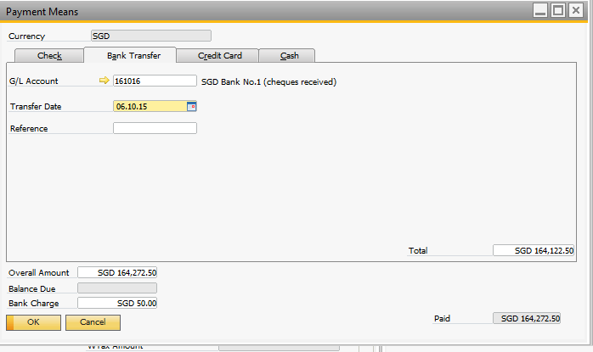
HKD
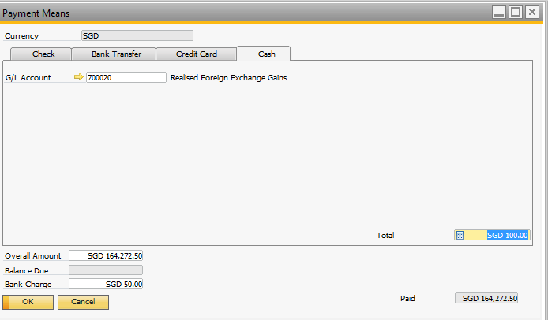
HKD
HKD
HKD
HKD
HKD
HKD
HKD
HKD

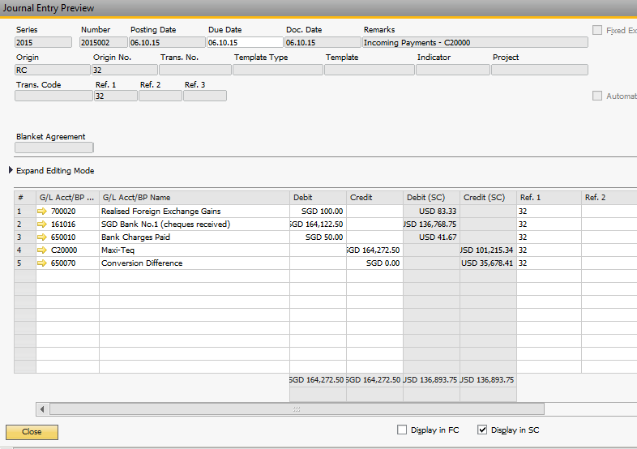
HKD
HKD
HKD
HKD
HKD
HKD
HKD

Sales & Purchase Process

HMMPL
- Medical Package
- HMMPL sells premium plan/package to corporate customer.
Double entry:
Dr customer
Cr Out-patient – Premium Plan
- Each corporate customer has only one insurance company (only applicable for consultation plan from Medjetco file)
- Invoice for the premium plan will be done in SAP
- Print invoice type “E” with free type description
- When patients visit panel clinic
- Patients do not need to pay and HMMPL claims the full amount from insurance company
Double entry:
Revenue $165
Cost of Sales $135 (different doctor has different cost)

Billing (AR)
Dr Customer $165
Cr Out-Patient – Consultation/AIA/VTC $165
(depends on the insurance company field in the customer card)

Reimbursement (A/P)
Cr clinic $135
Dr Cost of sales MBMS - OP Reimb to Dr $135
- Patients need to pay co-payment and HMMPL claims the revenue amount after the co-payment deduction.
Double entry:
Revenue $165
Cost of Sales $135 (different doctor has different cost)

Bill to Customer $145
Co-pay from Patient paid at Clinic $20

Billing (A/R)
Cr Out-Patient - Consultation $145
Dr Customer $145
* The remaining $20 of sales will be recognized at A/P

Reimbursement (A/P)
Dr Cost of sales MBMS - OP Reimb to Dr $135
Cr clinic $110
Cr Handling fee $5
Cr Out-Patient – Consultation/AIA/VTC $20
(depends on the insurance company field in the customer card)
- Based on transaction file from Medjetco MS007_SO, a journal entry will be passed to accrue the sales based on pay_comp amount. The journal is passed per customer, per incurred month
Double Entry:
Dr Accounts Receivable (Estimate), Cr Out-patient – Estimate
- In Medjetco MS007_SO, there will be OUT network transactions. A journal will be passed to estimate the cost of patient reimbursement.
Double Entry:
Cr Accounts Payable (Estimate), Dr Patient Reimbursement Cost – Estimate
- Operation team provides finance team with the transactions ready for billing. These transactions will be recorded in the same format as MS007_AR.
- These file will contains billing for vouchers from different incurred months. Based on this file, A/R invoice will be created with transactions in the same incurred month and company. Upon creation of invoice, the estimate sales journal will be reversed. Invoice type “M” will be printed. (invoice should show only the total billable amount for that particular incurred month)
- If the transactions belong to OUT network, A/R invoice will be created and the estimate cost journal will be reversed.
- Based on transaction file from Medjetco MS002_PO, a journal entry will be passed to accrue the doctor cost, admin fee and co-payment. The journal is passed per clinic, MBMS cost center and per incurred month
Double Entry:
Dr Cost of sales MBMS - OP Reimb to Dr Estimate
Cr Account payable (Estimate)
Cr Admin cost – Estimate
Cr Out-patient - Estimate
- Operation team provides finance team with the transactions ready for reimbursement. These transactions will be recorded in the same format as MS002_AP.
- These file will contains billing for vouchers from different incurred months. Based on this file, A/P invoice will be created with transactions per clinic, MBMS cost center and incurred month. Upon creation of invoice, the estimate cost journal will be reversed.
- If the voucher is split into multiple billing, HMMPL requires handle manually in SAP.
- If the insurance company rejects the claim, HMMPL will do a credit note manually in SAP.
- If the service is not covered by the insurance, HMMPL then will manually issue invoice type C from SAP to the customer for these charges.
- Reporting required:
- Premium against usage.
Based on the company code and clinic code in A/P invoice and A/R invoice, query for total A/R and A/P amount
Company code | clinic code | voucher number | incurred date | A/R amount | A/P amount
- Estimated sales amount for each corporate customer in the same incurred month based on sales order
Company code | incurred month | sales order amount
- Cap Plan
- Direct plan with customer with or without insurance company
- Invoice will be done in SAP
Double entry:
Dr customer
Cr advance received
- Print invoice type “E” with free type description
- They pay annually, quarterly, or monthly.
Double entry:
Dr bank
Cr customer
- Sales will be recognized on fix schedule.
Double entry:
Dr advance received
Cr Sales
- When MS007 is received, there is no billing to customer because the service is included in the plan. However, sales order will still be created to keep track of the details. Sales order will be closed immediately upon creation.
- The customer type will determine if the customer is under cap plan
- It is not possible that patient will use service which is not included in the plan.
- Reimbursement (A/P) transactions will be done based on MS002 interface file.
Double entry:
Cr clinic
Dr Cost of sales MBMS - OP Reimb to Dr
- Checkup
- Direct checkup plan with corporate customer or private customer with or without insurance company
Double entry:
Dr customer
Cr sales [Others - Vaccination, Checkup - Pre-employ, Checkup - Anl Checkup, Checkup – Individual]
- Invoice will be done in SAP. Invoice type A and P will be printed for annual checkup and pre-employment checkup respectively.
- It is possible that usage may exceed what is covered. If this happens, HMMPL will issue separate invoice from SAP to customer.
- Lab will send invoice to HMMPL for the services done by patients. This will be recorded manually in SAP as A/P invoice in total lump sum per A/P code.
Double entry:
Dr Reimburse to Lab
Cr clinic
- Vaccination
- Direct checkup plan with corporate customer or private customer without insurance company
Double entry:
Dr customer
Cr sales [Others - Vaccination, Checkup - Pre-employ, Checkup - Anl Checkup, Checkup – Individual]
- Invoice will be done in SAP. Invoice type O will be printed
- It is possible that usage may exceed what is covered. If this happens, HMMPL will issue separate invoice from SAP to customer.
- Lab will send invoices to HMMPL for the services done by patients. This will be recorded manually in SAP as A/P invoice in total lump sum per A/P code.
Double entry:
Dr Reimburse to Lab
Cr clinic
- Forms to be printed (Refer to appendix)
- Invoice Type E
Use footer 1.
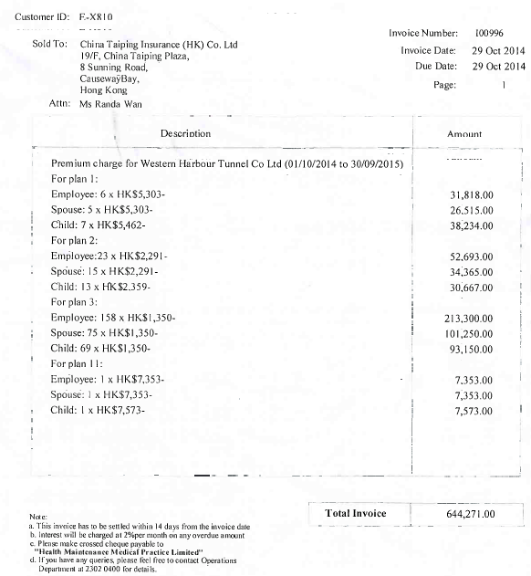
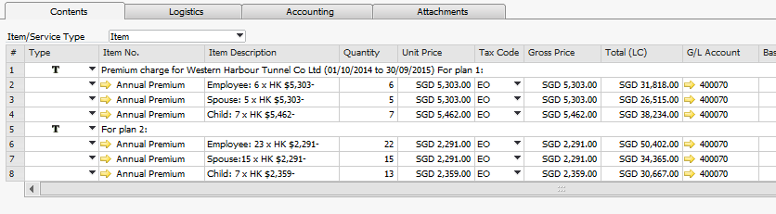
- Invoice Type M
Use footer 1. On the screen users will see multiple invoices in the same incurred month for this billing but they should not appear on the printed invoice.
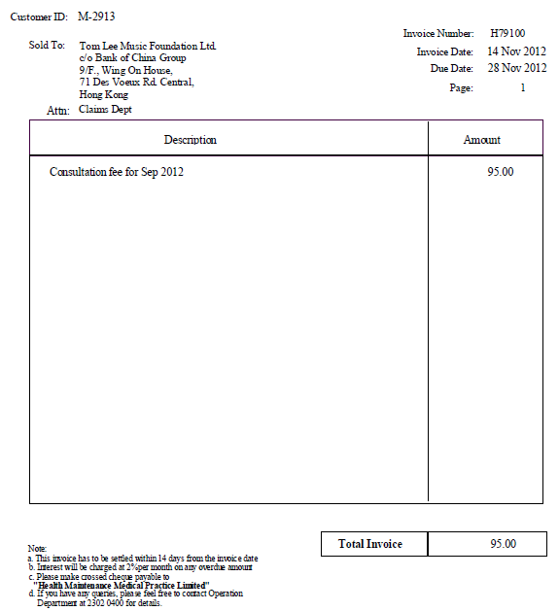
- Invoice Type A
Use footer 3 and free type description. Users can setup predefined description
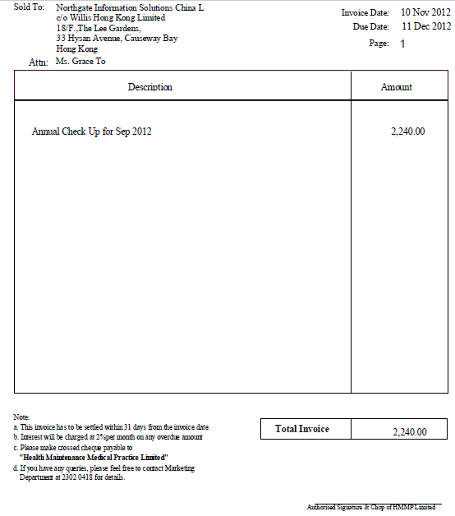
- Invoice Type P
Use footer 3 or 4 with free type description. Users can setup predefined description
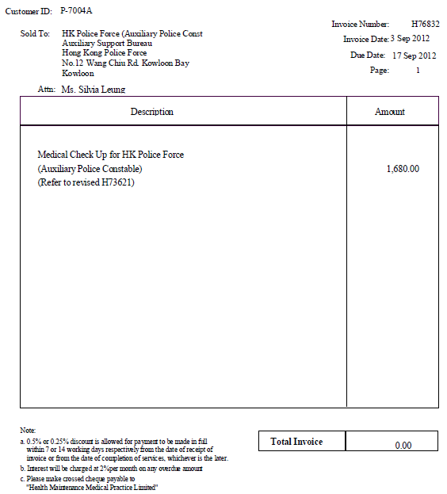
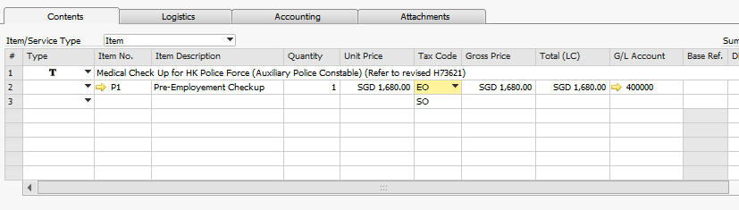
- Invoice Type C
Use footer type 2 with free type description. Users can setup predefined text using reject reason code but users require fill up the rest of the details.
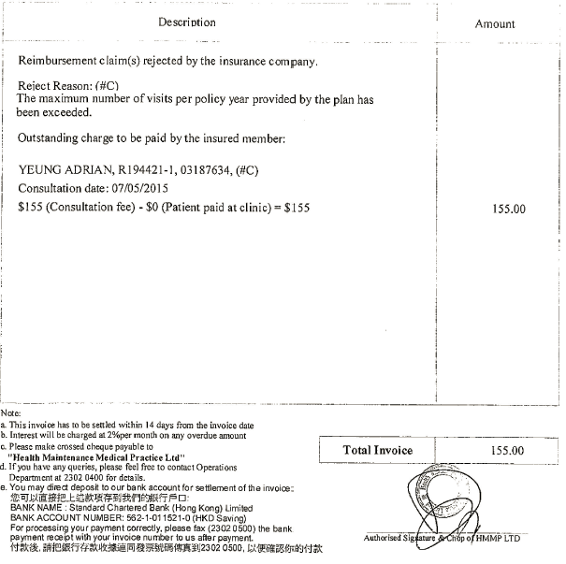
Predefined text
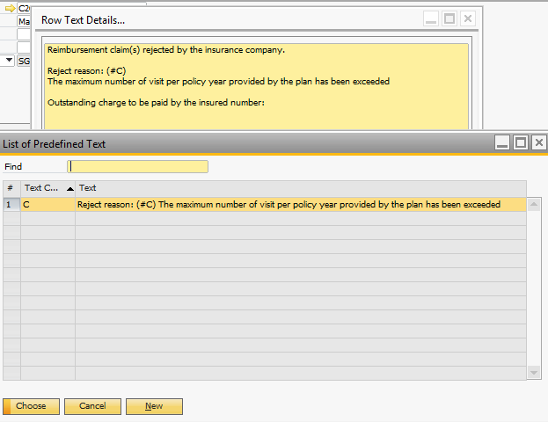
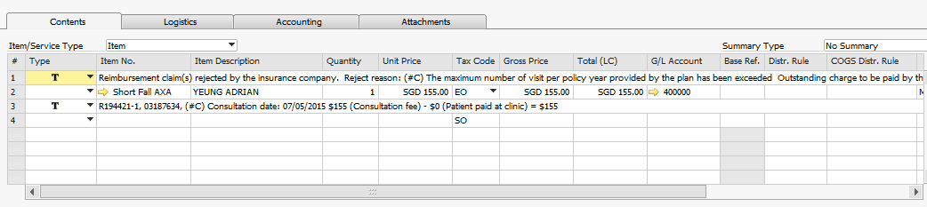
- Credit Note
Use footer 8 and free type description. User can setup predefined text.
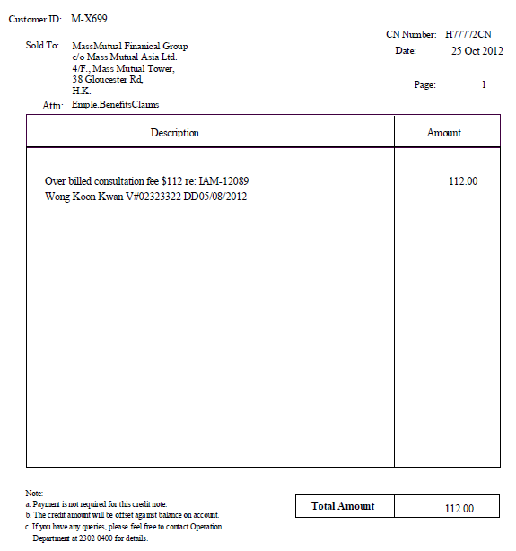
- FHG Receipt
Use existing template from FHG

HMDC
- There are 3 dental clinics. Please refer to clinic cost center
- Contract customer
- After HMMPD sells plan to corporate customers, patients go to HMDC clinics for dental service.
- Primary income
- Patients do not need to pay
- HMDC will claim 80% of the charges from HMMPD to reimburse doctor (A/R invoice created under HMMPD)
- The customer type in RD001 file will be “Contract” and the pay_comp will contain amount
- Double entry for HMDC
Dr HMMPD
Cr Income – Contract
- Secondary income
- Patients need to pay partially because some service is not included in the plan.
- HMDC need to pay 20% of these fees, which was chargeable to patients, back to HMMPD through A/P invoice. This will serve as sales for HMMPD.
- Invoice will be created under HMMPD.
- A/R invoice + incoming payment will be at the same time created to recognize the sales.
- The customer type in RD001 file will be “Contract” and the pay_client will contain amount
- Double entry for HMDC
A/R invoice + incoming payment:
Dr payment method (Cash, Card, Autopay, Cheque), Cr Income – Contract
Cr payment method, Dr clinic default bank

A/P invoice:
Cr HMMPD, Dr Others - Admin fee (cost)
- Primary and secondary income could happen together in same transaction
- Private customer
- No contract and patients need to pay for the dental service
- The customer type in RD001 file will be “PRIV” and the pay_client will contain amount
- Double entry for HMDC
Dr payment method (Cash, Card, Autopay, Cheque), Cr Income - Private
- Salary to doctor together with commission will be done manually in SAP, through A/P or outgoing payment directly.
Double entry for A/P and outgoing payment:
Cr doctor
Dr Doctors salary
Dr Commissions On Sales

Dr Doctor
Cr bank

Double entry for outgoing payment directly:
Cr bank
Dr Doctors salary
Dr Commissions On Sales

YOT
- This entity is not owned under HMMP group.
- There are total 4 dental clinics, which 3 of them are owned by HMMS. Please refer to clinic cost center
- Business flow same as HMDC, except YOT provides dental services to non-profit organization
- YOT claims from government funding (For eg CSSA) for the dental services provided.
Double entry:
Dr Government fund (for eg CSSA)
Cr Income - CSSA
(some customers have specific revenue account)
- It also possible that patients walk in for dental service with the fund given by government. In such scenario, YOT does not claim from government fund.
Double entry:
Dr payment method (Cash, Card, Autopay, Cheque)
Cr CSSA Walk in (Follow customer type in RD001)

Dr bank
Cr payment method (Cash, Card, Autopay, Cheque)
- Salary to doctor together with commission will be done manually in SAP, through A/P or outgoing payment directly.
Double entry for A/P and outgoing payment:
Cr doctor
Dr Doctors salary
Dr Commissions On Sales

Dr Doctor
Cr Bank

Double entry for outgoing payment directly:
Cr bank
Dr Doctors salary
Dr Commissions On Sales
- YOT will give the net profit to HMMS manually in AP, after deducting admin fee which will serve as revenue for YOT from the net profit

HMMPD
- Broker and insurance companies sell dental package to corporate customers. Invoice will be done in SAP.
- It is also possible HMMPD directly sells contract to corporate customers. Invoice will be done in SAP.
- Revenue from customer
- compulsory package
- compulsory package bought for employee
Double entry:
Dr customer
Cr Income - Package
- voluntary
- additional service bought by employee like for their families
Double entry:
Dr customer
Cr Income - Voluntary
- transaction
- corporate don’t pay first, HMMPD need to bill after visit
- Issue A/R invoice manually in SAP.
Double entry:
Dr customer
Cr Income – By Visit
- Contract customer
- When HMMPD sells package to corporate customer, patients go to HMDC or YOT clinics for dental service.
- Primary income
- Patients do not need to pay
- HMDC/YOT will claim 80% of the charges from HMMPD to reimburse doctor. (A/P invoice)
- The customer type in RD001 file will be “Contract” and the pay_comp will contain amount
- A/P invoice will be created under clinic (A/P code)
- Double entry
Cr HMDC/YOT clinic
Dr COS - Reimbursement
- Secondary income
- Patients need to pay partially because some service is not included in the contract.
- HMDC need to pay 20% of these fees, which is chargeable to patients, back to HMMPD (A/R invoice).
- The customer type in RD001 file will be “Contract” and the pay_client will contain amount
- A/R invoice will be created under clinic code (A/P code)
- Double entry
Dr HMDC/YOT clinic
Cr Income – Admin Fees
- Primary and secondary income could happen together in same transaction.
- Forms required
- A/R Invoice type P & T
Fix footer and free type description
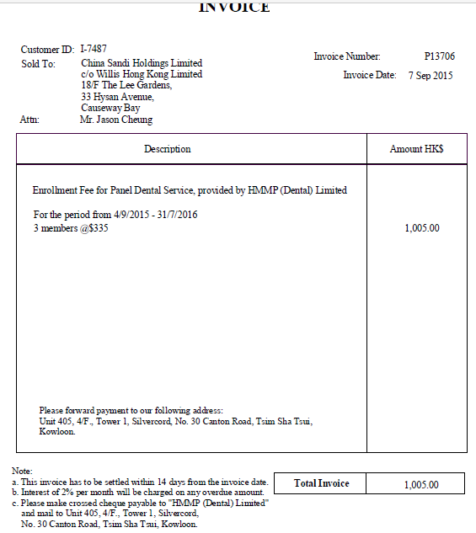

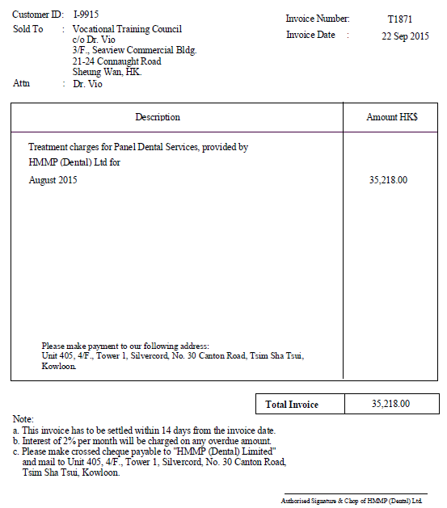
- Credit Note
Printed from A/R Credit Note screen, fix footer and free type description

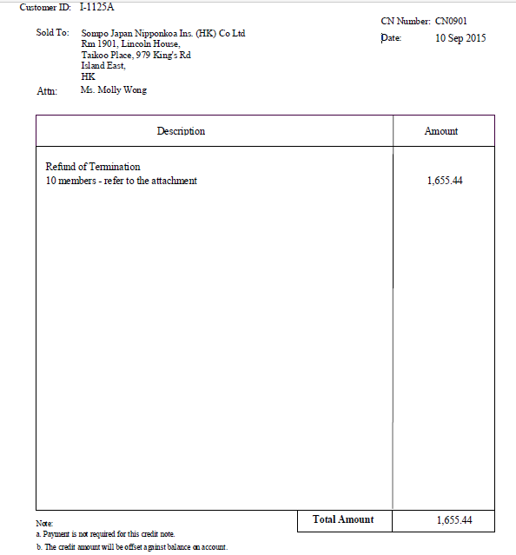
- Receipt – 1022
Printed from A/R invoice screen and fix footer
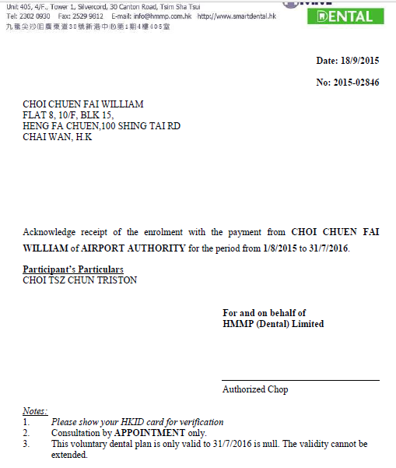
Free type payee and address in A/R invoice screen
Invoice date
Invoice No
Get the ending period from the plan
Free text in A/R invoice screen
Customer name as per customer card that the A/R invoice is billed to
- Receipt Normal
Printed from A/R Invoice screen and fix footer
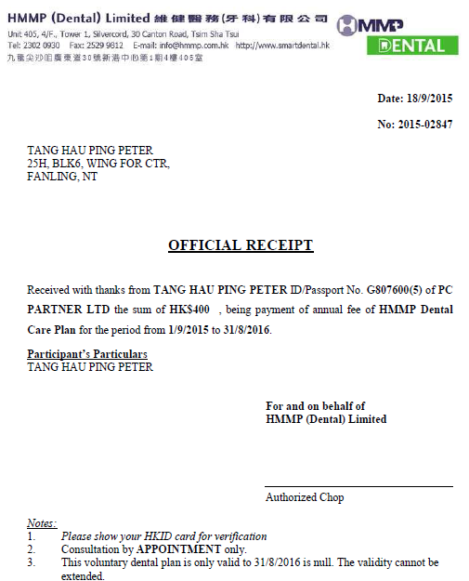
Invoice date
Invoice No
Free type payee and address in A/R invoice screen
Get the ending period from the plan
Customer name as per customer card that the A/R invoice is billed to
Free text in A/R invoice screen
Invoice amount
- Receipt AXA400
Printed from incoming payment screen
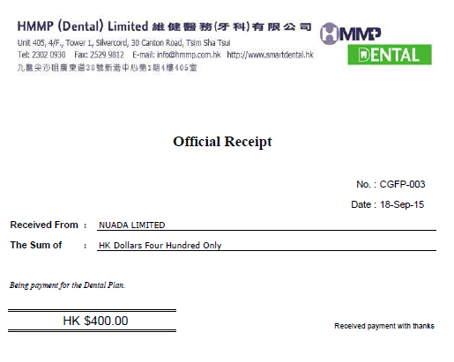
Receipt No
Receipt Date
Customer name from customer card
Receipt amount
- FHG Receipt
Use existing template from FHG

- Reporting required
- Premium against usage.
Based on the company code and clinic code in A/P invoice and A/R invoice,
query for total A/R and A/P amount
Company code | clinic code | voucher number | incurred date | A/R amt | A/P amt

Inventory

Service Items
- Service item Master Data is created for revenue type where sales GL accounts are defined. For example “Pre-Employement Checkup”, “Annual Premium”, “Short Fall AXA”, “Outpatient – Consultation”.
- Item properties set to “Service”
- You can group your services into different categories to filter reports.

Inventory Items
- Inventory is maintained in SAP for HMDC and YOT and will have item master data for the products purchased and delivered.
- Item properties set to “Inventory”
- Item group is useful to filter reports. Group the products into different categories
- HMDC and YOT have one warehouse each.
- Some inventory items are managed by batch and it requires batch number when receiving and issuing goods.
- Users require maintain expiration date and purchase price for each batch as attributes. Alert users 60 days before expiration.
- Item cost will be calculated using FIFO at batch level.
- HMDC and YOT do not earn from selling products. They purchase products and delivery to clinic. It will not involve A/R.
A/P: Dr inventory, Cr AP
Goods issue: Cr inventory, Dr Cost of sales - FFS Dental Supplies (user can change GL account)
- Users request to have upload program to record stock movement. This includes AP invoices to increase the stock and goods issue to deduct the stock. (Change request)
- No discount involved for all products and treatment at sales and purchase. They will be always net price.

Customer & Vendor Master Data
- Each corporate customer will be created as master data in SAP. For eg X810 “China Taiping Insurance (HK) Co. Ltd”
- Insurer and MBMS cost center for each company will be set at user defined table as below. Effective date is required so that the correct MBMS cost center will be assigned based on incurred date when Medjetco file is uploaded. Users need to maintain this table manually.
Name: MBMS
Code | Name | company_code | Insurer | MBMS | Effective_Date
1 | 1 | X001 | AXA | AXA | 01012015
2 | 2 | X002 | MSIG | MSIG | 02052015
3 | 3 | X001 | MSIG | MSIG | 30062015
4 | 4 | X003 | XXXX | OTHERS | 01012015
- In current practice, certain companies are assigned to a specific revenue account based on the insurance company. In future, this will be replaced with MBMS cost center. They will be posted to the same revenue account and users will make use of the cost center report to get breakdown.
- Customer type for example Cap plan will be set as UDF “U_Type”
- Doctor may or may not be created as vendor.
Group Type | Group Name | Coding | Purpose
Customer Group | AXA  MSIG  ..  Interco | Cxxxx  Interco - ZCxxxx  (followed by existing) | Customer group is required for filtering purpose in generating report, also to generate SOA by insurance company  To differentiate external and internal customers.
Vendor Group | Local and Interco | Local - Vxxxx  Interco - ZVxxxx  (followed by existing) | To differentiate external and internal vendors.
- Clinic can be A/R and A/P. For example in HMMPD, the 80% of reimbursement and 20% of sales claim from HMDC/YOT clinics will be used to knock off each other. Separate master data must be maintained with different codes for the same clinic. One will serve as customer, one will serve as vendor.
- At customer master data in YOT, require a field to define the default revenue item code. For example: Income - CSSA
- It is required to use harmonized customer and vendor code across the group with prefix C/ZC for customers and V/ZV for vendors. You require add the prefix to the existing code. For eg: if the existing customer code is X109, in SAP it will be CX109

Medjetco Interface to SAP

Work Flow
Medjetco
HMMPL
Database
Integration

Folder:
- Inputl
- Success
- Failed
- ErrorLog
- DebugLog

Process Documentation
- Integration process is one way (Medjetco to SAP), using Excel file format. There are 5 folders need to be created on Virtual Machine server (to be provided by FHG)
- Input. This folder will keep the original file from Medjetco System (excel file) before imported to SAP Business One system. Users will manually drop the files to be imported in this folder.
- Success. This folder consists of all successful imported transactions.
- Failed. This folder consists of all fail imported transactions.
- Error Log. This folder consists of error information.
- Debug Log. This folder consists of all process log file, used to analyze any problems.
- After users review data, they will save the excel files into virtual machine server source folder (“INPUT”).
- Integration program will get the data from the “INPUT” folder and send the file to backend tables.
- The integration process starts reading from in “INPUT” folder.
- If integration process is successful, then integration add-ons will move the file into “SUCCESS” folder;
- If integration process is unsuccessful, will move the file into “FAILED” folder. Integration add-ons will send an email consists of error file and error log automatically to defined recipients in configuration table. Users shall be able to make correction in this file and re-import again.
- Users will manually trigger the integration program.
- Integration program output created are as follows:
- Backend sales orders and SAP A/R invoice under companies to claim from insurance company (Based on MS007).
- SAP A/P invoice to reimburse patient (Based on MS007)
- Backend purchase orders and SAP A/P invoice to reimburse doctor (Based on MS002)
- Journal entries in SAP to estimate sales and cost.
- After successful creation of above documents from the integration program, SAP user will run the following procedures in SAP.
- Journal entry for the HKD8 processing fees for TPA/Outnetwork
- Monthly payment to doctors (AP Invoice net of Administration Fee)
- Payment to patients
- Incoming payment upon receiving payment from insurance company
- Automation for receipt settlement using upload program (Change request)
- Adjustments (if any) are to be done directly in SAP Business One system.
- Document changes and cancellation. If there is any changes have been done in any document (AR Invoice, AP Invoice and Payment), users have to cancel SAP documents and re-enter the transactions manually in SAP. System will automatically change the system number during cancellation of document.
- File name convention will be:
“MS007_SO_[last day of the month]” For eg: MS007_SO_31102015
“MS007_AR_[last day of the month]”
“MS002_PO_[last day of the month]”
“MS002_AP_[last day of the month]”

Master Data
One time migration of customer data will be executed in SAP. Users will manually maintain the customer data in SAP in future

Data Processing

Sales Estimate
- Based on input file MS007_SO_[last day of the month]
- Data in this file will be created in backend table. Refer to data mapping “Sales Order Details”
- Based on the backend table, the program will calculate the total sales for each company code per incurred month (using txn_date to retrieve month). Refer to data mapping “Sales Accrual”
- A journal entry will be passed to accrue sales for each company. The amount will be pay_comp amount. Refer to data mapping “Estimated sales journal”. Exclude customer type “Capitation” and if the clinic code start with “OUT”
- Based on this file, calculate also the total cost for each clinic which clinic code start from “OUT” per incurred month (using txn_date to retrieve month). Refer to data mapping “Cost Accrual”. A journal entry will be passed to accrue reimbursement cost to patient. The amount will be pay_comp amount. Refer to data mapping “Estimated cost journal”.

A/R Invoice
- Based on MS007_AR_[last day of the month]
- Data in this file will be created in backend table. Refer to data mapping “AR Invoice Details”
- This file will contain information which tells vouchers to be billed. It is possible to have vouchers from different incurred month.
- If pay_comp has amount, create an A/R invoice for each company_code and incurred month (Using txn_date to retrieve incurred month) and the amount will be total pay_comp. Exclude for clinic code start with “OUT”
- Close the voucher by updating the status to “C” and the SAP invoice number which the voucher is billed at backend “Sales Accrual” table with the voucher number as the key as long as there is billing done for this voucher, regardless whether there will be discrepancy or not. Assume that each voucher will not be split into multiple billing. At the same time the estimated sales journal passed during 8.4.1 will be reversed (Data mapping Reversal of estimated sales journal).
- Based on this file, if clinic code start from “OUT”, create A/P invoice (refer to configuration table “Item Code”.
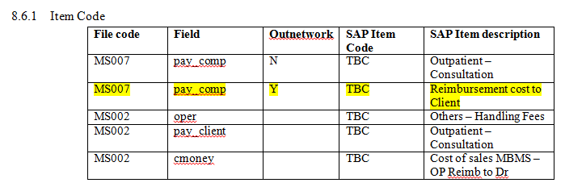
Also, reverse the cost accrual passed during 8.4.1. Refer to data mapping “Cost Accrual”.
- If voucher number cannot be found in “Sales Accrual” and “Cost Accrual”. No reversal is required.
- Cap plan transactions will not exist in this file.

Cost Estimate
- Based on input file MS002_PO_[last day of the month]
- Data in this file will be created in backend table. Refer to data mapping “Purchase Order Details”
- Based on the backend table, the program will calculate the total cost, admin fees and sales for each clinic code per incurred month (using txn_date to retrieve month). Refer to data mapping “Cost Accrual”
- A journal entry will be passed to accrue cost, admin fees and income for each clinic. Refer to data mapping “AP Estimated cost journal”.
- New requirement
If the company_code belong to “Fee For Services” type (UDF “U_Type” in master data), cmoney will be posted to Reimbursement to doctor (FFS) Estimate, oper will be posted to Handling Fees Estimate, pay_client will be posted to Estimate Income - Fee for service

If the company_code belong to “Capitation” type, pay_client will be posted to Estimate Income – Fee for service, oper will be posted to Handling Fees Estimate, cmoney will be posted to Reimbursement to doctor (Capitation) Estimate

Refer to configuration table AP Estimated cost G/L

A/P Invoice
- Based on MS002_AP_[last day of the month]
- Data in this file will be created in backend table. Refer to data mapping “AP Invoice Details”
- This file will contain information which tells vouchers to be reimburse to doctor. It is possible to have vouchers from different incurred month.
- Create an A/P invoice for each clinic_code and incurred month (Using txn_date to retrieve incurred month) and the amount will be total cmoney, oper and pay_client
For eg:
Dr Cost of sales MBMS – OP Reimb to Dr $170 (column U)
Cr Others – Admin fee $7.60 (column R)
Cr Outpatient – Consultation $45 (column Q)
Cr clinic $117.40 (column T)
- Close the voucher by updating the status to “C” and the SAP invoice number which the voucher is billed at backend “Cost Accrual” table with the voucher number as the key as long as there is reimbursement done for this voucher, regardless whether there will be discrepancy or not. Assume that each voucher will not be split into multiple reimbursements. At the same time the estimated cost journal passed during 8.4.3 will be reversed. (Data mapping Reversal of estimated sales journal).
- If voucher number cannot be found in “Cost Accrual”. No reversal is required.
- New requirement
- If the company_code belong to “Fee For Services” type (UDF “U_Type” in master data), cmoney will be posted to Reimbursement to doctor (FFS), oper will be posted to Handling Fees, pay_client will be posted to Income - Fee for service
- If the company_code belong to “Capitation” type, pay_client will be posted to Income – Fee for service, oper will be posted to Handling Fees, cmoney will be posted to Reimbursement to doctor (Capitation)

Refer to configuration table Item Code

New Requirements 23122015

Current logic

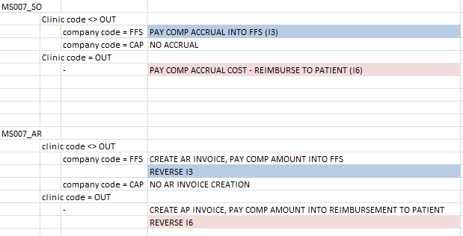
New Logic:

Revised
MS007_SO
 | Clinic code not in the TPA listing (@AE_TPA_APCODE)
 |  | company code = FFS | PAY COMP ACCRUAL INTO FFS (D3)  PER COMPANY CODE, INCURRED MONTH, MBMS  @AE_MS007_GL
 |  | company code = CAP | NO ACCRUAL
 | Clinic code in the TPA listing (@AE_TPA_APCODE)
 |  | company code = CAP | PAY COMP ACCRUAL COST - REIMBURSE TO PATIENT (D6)  PER CLINIC CODE, INCURRED MONTH, MBMS, TYPE (CAPITATION)  DR REIMBURMENT TO PATIENT, CR Accrued COGS (Panel)  @AE_OUT_REV_GL
 |  | company code <> CAP | DR AR, CR TPA INCOME (PAY COMP) (D7)  PER CLINIC CODE, INCURRED MONTH, MBMS, TYPE (FFS)  NEW TABLE: @AE_OUT_GLAR_NONCAP
CR AP, DR TPA INCOME (PAY COMP) (D8)
PER CLINIC CODE, INCURRED MONTH, MBMS, TYPE (FFS)
NEW TABLE: @AE_OUT_GLAP_NONCAP
 |  |  | MANUALLY PASS ENTRY FOR TPA INCOME ($12) (D9)
MS007_AR
 | Clinic code not in the TPA listing (@AE_TPA_APCODE)
 |  | company code = FFS | CREATE AR INVOICE UNDER COMPANY CODE, PAY COMP AMOUNT INTO FFS  PER COMPANY CODE, INCURRED MONTH, MBMS  @AE_ITEMCODE, FILE CODE = MS007, OUTNETWORK = N
REVERSE D3
@AE_MS007_GL_REV
 |  | company code = CAP | NO AR INVOICE CREATION
 | Clinic code in the TPA listing (@AE_TPA_APCODE)
 |  | company code = CAP | CREATE AP INVOICE UNDER AP CODE IN CONFIGURATION TABLE (@AE_TPA_APCODE), PAY COMP AMOUNT INTO REIMBURSEMENT TO PATIENT  PER APCODE, INCURRED MONTH  MBMS AT LINE LEVEL (PENDING IT CONFIRMATION)  @AE_ITEMCODE, FILE CODE = MS007, OUTNETWORK = Y, TYPE = Capitation
 |  |  | REVERSE D6
 |  | company code <> CAP | CREATE AR INVOICE UNDER COMPANY CODE, PAY COMP AMOUNT INTO TPA INCOME  PER COMPANY CODE, INCURRED MONTH, MBMS  @AE_ITEMCODE, FILE CODE = MS007, OUTNETWORK = Y, TYPE <> Capitation
REVERSE D7
NEW TABLE: @AE_OUT_GLAR_NONCAP
 |  |  | CREATE AP INVOICE UNDER CLINIC CODE (OUT), PAY COMP AMOUNT INTO TPA INCOME
 |  |  | REVERSE D8
 |  |  | MANUAL INVOICE UNDER (1306) FOR $12, MANUAL REVERSE D9
New File: MS007_AR(P)
 | Clinic code in the TPA listing (@AE_TPA_APCODE)
 |  | company code <> CAP
 |  |  | CREATE AP INVOICE UNDER AP CODE IN CONFIGURATION TABLE (@AE_TPA_APCODE), PAY COMP AMOUNT INTO TPA INCOMEPER APCODE, INCURRED MONTH, TYPE (FFS)MBMS AT LINE LEVEL (PENDING IT CONFIRMATION)@AE_ITEMCODE, FILE CODE = MS007, OUTNETWORK = Y, TYPE <> Capitation
REVERSE D8
NEW TABLE: @AE_OUT_GLAP_NONCAP
 |  | company code = CAP | CREATE AP INVOICE UNDER AP CODE IN CONFIGURATION TABLE (@AE_TPA_APCODE), PAY COMP AMOUNT INTO REIMBURSEMENT TO PATIENT  PER APCODE, INCURRED MONTH, TYPE (CAPITATION)  MBMS AT LINE LEVEL (PENDING IT CONFIRMATION)  @AE_ITEMCODE, FILE CODE = MS007, OUTNETWORK = Y, TYPE = Capitation
 |  |  | REVERSE D6
MS002_PO
 |  | company code <> CAP
ACCRUAL CMONEY, OPER, PAY_CLIENT (D36)
PER CLINIC CODE, INCURRED MONTH, TYPE (FFS)
MBMS AT LINE LEVEL (PENDING IT CONFIRMATION)
@AE_MS002_GL
DR FFS Panel Provider (cmoney)
CR Admin Fee (oper)
CR Fee For Services (pay_client)
CR AP
 |  | company code = CAP
ACCRUAL CMONEY, OPER, PAY_CLIENT (D38)
PER CLINIC CODE, INCURRED MONTH, TYPE (CAPITATION)
MBMS AT LINE LEVEL (PENDING IT CONFIRMATION)
@AE_MS002_GL
DR CAP - Panel Provider Fee (cmoney - pay_client)
DR FFS Panel Provider (pay_client)
CR Fee For Services (pay_client)
CR Admin Fee (Oper)
Cr AP
MS002_AP
 |  | company code <> CAP
AP INVOICE UNDER AP CODE FOR CMONEY, OPER, PAY_CLIENT (D32)
PER AP CODE, INCURRED MONTH, TYPE (FFS)
MBMS AT LINE LEVEL (PENDING IT CONFIRMATION)
Posting as per D36, Except AP changed from estimate payable to actual AP payable account
 |  |  | REVERSE D36
 |  | company code = CAP
AP INVOICE UNDER AP CODE FOR CMONEY, OPER, PAY_CLIENT (D32)
PER AP CODE, INCURRED MONTH, TYPE (CAPITATION)
MBMS AT LINE LEVEL (PENDING IT CONFIRMATION)
Posting as per D86, Except AP changed from estimate payable to actual AP payable account
 |  |  | REVERSE D38

Sales/Purchase Order Details created in backend table
Estimated Sales Journal per company code
Estimated cost, admin fees and sales journal per clinic code
Upload
MS007_SO_YYYYMMDDHHMMSS
MS002_PO_YYYYMMDDHHMMSS
Into Input folder
Trigger Integration Process
Start reading
MS007_SO_YYYYMMDDHHMMSS
MS002_PO_YYYYMMDDHHMMSS
In Input folder
Write error and success log
Remove files from Input folder and move to “Failed” or “Success”
Upload
MS007_AR_YYYYMMDDHHMMSS
MS002_AP_YYYYMMDDHHMMSS
Into Input folder
Trigger Integration Process
Start reading
MS007_AR_YYYYMMDDHHMMSS
In Input folder
h
A/R invoice created per company per incurred month
Reverse sales accrual
Email Notification
Start reading
MS002_AP_YYYYMMDDHHMMSS
In Input folder
A/P invoice created per clinic per incurred month
Reverse cost accrual
Write error and success log
Email Notification
Re-upload failure
Re-upload failure
First Upload
Second Upload
Remove files from Input folder and move to “Failed” or “Success”

Configuration file

DB Name
Name | DB
HMMPL | HMMPL_LIVE

Configuration table (UDT)

Item Code
File code | Outnetwork | Type | Field | SAP Item Code | SAP Item description | Debit/Credit
MS007 | N |  | pay_comp | 4-32000-00 | Income - Fee for service
MS007 | Y | Capitation | pay_comp | 5-31050-00 | Reimbursement cost to Client
MS007 | Y |  | pay_comp | 4-53000-00 | TPA Admin Fee
MS002 |  |  | Oper  (negative) | 4-35000-00 | Admin Fee | Credit
MS002 |  | Capitation | Oper  (negative) | 4-35000-00 | Admin Fee | Credit
MS002 |  |  | pay_client  (negative) | 4-32000-00 | Income - Fee for service | Credit
MS002 |  | Capitation | pay_client  (negative) | 4-32000-00 | Income - Fee for service | Credit
MS002 |  | Capitation | pay_client | 5-32010-00 | FFS Panel Provider fee | Debit
MS002 |  |  | cmoney | 5-32010-00 | FFS Panel Provider fee | Debit
MS002 |  | Capitation | cmoney-pay_client | 5-31010-00 | CAP – panel provider fee | Debit

Estimated sales G/L
File code | G/L Code | G/L Name | Debit/Credit
MS007 | TBC  1-15000-00 | Accounts Receivable (Estimate) | Debit
MS007 | TBC  4-32000-00 | Out-patient – Estimate | Credit

Reversal of estimates sales G/L
File code | G/L Code | G/L Name | Debit/Credit
MS007 | TBC  1-15000-00 | Accounts Receivable (Estimate) | Credit
MS007 | TBC  4-32000-00 | Out-patient – Estimate | Debit

AR Estimated cost G/L
File code | Field | G/L Code | G/L Name | Debit/Credit
MS007 |  | TBC  2-15100-00 | Accounts Payable (Estimate) | Credit
MS007 | pay_comp  5-31050-00 | TBC | Patient Reimbursement Cost – Estimate | Debit

AR Reversal of estimates cost G/L
File code | Field | G/L Code | G/L Name | Debit/Credit
MS007 |  | TBC | Accounts Payable (Estimate) | Debit
MS007 | pay_comp | TBC | Patient Reimbursement Cost – Estimate | Credit

AP Estimated cost G/L

File code | Type | Field | G/L Code | G/L Name | Debit/Credit
MS002 |  |  | 2-15100-00 | Accounts Payable (Estimate) | Credit
MS002 |  | Oper | 4-35000-00 | Admin Fee | Credit
MS002 | Capitation | Oper | 4-35000-00 | Admin Fee | Credit
MS002 |  | pay_client | 4-32000-00 | Income - Fee for service | Credit
MS002 | Capitation | pay_client | 4-32000-00 | Income - Fee for service | Credit
MS002 | Capitation | pay_client | 5-32010-00 | FFS Panel Provider fee | Debit
MS002 |  | cmoney | 5-32010-00 | FFS Panel Provider fee | Debit
MS002 | Capitation | cmoney-pay_client | 5-31010-00 | CAP – panel provider fee | Debit

AP Reversal of estimates cost G/L

File code | Type | Field | G/L Code | G/L Name | Debit/Credit
MS002 |  |  | 2-15100-00 | Accounts Payable (Estimate) | Debit
MS002 | Fee For Services | Oper | 4-35000-00 | Admin Fee | Debit
MS002 | Capitation | Oper | 4-35000-00 | Admin Fee | Debit
MS002 | Fee For Services | pay_client | 4-32000-00 | Income - Fee for service | Debit
MS002 | Capitation | pay_client | 4-32000-00 | Income - Fee for service | Debit
MS002 | Capitation | pay_client2 | 5-32010-00 | FFS Panel Provider fee | Credit
MS002 | Fee For Services | cmoney | 5-32010-00 | FFS Panel Provider fee | Credit
MS002 | Capitation | cmoney-pay_client | 5-31010-00 | CAP – panel provider fee | Credit

AP code for OUT network
BP code | BP Name
OUT | OUT network

AR_Footer
Field | Value
OINV.U_Footer | 1

Email
Name | Email
Olive Yeung | oliveyeung@hmmp.com.hk
Ally Lau | allylau@hmmp.com.hk

@AE_OUT_GLAP_NONCAP
File code | Field | G/L Code | G/L Name | Debit/Credit
MS007 |  | 2-15100-00 | Accrued COGS (Panel) | Credit
MS007 | pay_comp | 4-53000-00 | TPA - Admin fee | Debit

@AE_OUT_GLAR_NONCAP
File code | Field | G/L Code | G/L Name | Debit/Credit
MS007 |  | 1-15000-00 | Accrued revenue | Debit
MS007 | pay_comp | 4-53000-00 | TPA - Admin fee | Credit

@AE_TPA_APCODE

Clinic Code (U_cln_code) | AP Code (U_ap_code)
3010 | VTPA
OUT1 | VOUT
OUT3 | VOUT

Data Mapping

Sales Order Details based on “MS007_SO__[last day of the month]”
Copy everything from excel file and put into backend table with below additional column created
      - “OcrCode” to retrieve MBMS cost center from UDT “MBMS” using company_code and txn_date > effective_date
UDT Name: MBMS
Code | Name | company_code | Insurer | MBMS | Effective_Date | End_Date
1 | 1 | X001 | AXA | AXA | 01012015
2 | 2 | X002 | MSIG | MSIG | 02052015 | 31122015
3 | 3 | X001 | MSIG | MSIG | 30062015 | 31122099
4 | 4 | X003 | XXXX | OTHERS | 01012015

      - “Insurer” to retrieve insurer from UDT “MBMS” using company_code and txn_date > effective_date (the last insurance company)
      - “incurred_month” to convert the txn_date to last day of the month. For eg: if txn_date is 24102015, incurred_month wll be 31102015.
      - “ar_code” to indicate the SAP BP code for the customer. Retrieve BP code which foreign name is company_code.
      - “ap_code” to indicate the SAP BP code for the clinic. BP code = “V” + cln_code
      - “Type” to be retrieved from UDF “U_Type” from master data based on company_code (For eg: Fee For Service, Capitation)

Sales Accrual based on Sales Order Details
Source (Sales Order Details) | Backend table field name | Remarks
company_code | company_code
ar_code | ar_code
type | type | Fee For Service, Capitation
Incurred_month | incurred_month
OcrCode | OcrCode | MBMS cost center
Insurer | Insurer
invoice | invoice | Voucher number
- | total_sales | Sum of pay_comp amount per invoice
- | status | Update to “C” if the billing for the invoice has been done. By default it will be “O”
- | sap_invoice | SAP invoice number which the billing for the voucher is created.

Example:
Company Code | ar_code | Incurred month | MBMS | Insurer | Invoice | Total Sales | Status | SAP Invoice No
69EJ | C00001 | 31102015 | AXA | AXA | 03246228 | 500.00 | O
69EJ | C00001 | 31102015 | AXA | AXA | 03232663 | 132.00 | C | 151000001

Estimated sales journal based on Sales Accrual created per company code, incurred month and MBMS
SAP | SAP Field Name | Remarks
Posting Date | OJDT.RefDate | Sales Accrual.incurred_month
Document Date | OJDT.TaxDate | Sales Accrual.incurred_month
Remarks | OJDT.Memo | “Estimated Sales for ” + Sales Accural.company_code  For eg: Estimated sales for X0102
G/L Account | JDT1.Account | Refer to configuration table “Estimated Sales”
Debit | JDT1.Debit | Sales Accrual.total_sales
Credit | JDT1.Credit | Sales Accrual.total_sales
MBMS | JDT1.ProfitCode | Sales Accrual.OcrCode, only if it is credit

**if clinic_code in “Sales Order Details” exist in @AE_TPA, go to “cost accrual”

AR Invoice Details based on “MS007_AR__[last day of the month]
Copy everything from excel file and put into backend table with below additional column created
- “OcrCode” to retrieve MBMS cost center from customer master data using company_code
- “Insurer” to retrieve insurer from UDT “MBMS” using company_code and txn_date > effective_date
- “SAP_Invoice” to keep track of the SAP invoice number created for the vouchers, updated when A/R invoice is created.
- “incurred_month” to convert the txn_date to last day of the month
- “ar_code” to indicate the SAP BP code for the customer. Retrieve BP code with prefix. For eg: if the company code in file is X109, in SAP it will be CX109
- “ap_code” to indicate the SAP BP code for the clinic. “V” + cln_code
- “Type” to be retrieved from UDF “U_Type” from master data based on company_code (For eg: Fee For Service, Capitation)

AR Invoice in SAP based on “AR Invoice Details”, created per company code, incurred month and MBMS
SAP | SAP Field Name | Remarks
Customer Code | OINV.CardCode | AR Invoice Details.ar_code
Currency | OINV.DocCur | Default currency set for customer
Posting date | OINV.DocDate | [last day of the month] from file name
Item code | INV1.ItemCode | Refer to configuration table Item Code “MS007 pay_comp”
Tax Code | INV1.VatGroup | Default tax group set for customer
Line Total | INV1.LineTotal | Sum of AR Invoice Details.pay_comp per company code and incurred month
MBMS | INV1.OcrCode | AR Invoice Details.OcrCode
MBMS COGS | INV1.CogsOcrCode | Same as OcrCode
Insurer | OINV.U_Insurer
Footer | OINV.U_Footer | Refer to configuration table “AR_Footer”

Reversal of estimated sales journal in SAP. Retrieve the amount from Sales Accrual using invoice number in “AR Invoice Details”. Journal will be passed per company code, incurred month, and MBMS
SAP | SAP Field Name | Remarks
Posting Date | OJDT.RefDate | Last day of the month in the file name. For eg: MS007_AR__[31102015]
Document Date | OJDT.TaxDate | Same as posting date
Remarks | OJDT.Memo | “Reversal of Estimated Sales for ” + Sales Accural.company_code  For eg: Reversal of Estimated sales for X0102
G/L Account | JDT1.Account | Refer to configuration table “Reversal of estimated sales G/L”
Debit | JDT1.Debit | Sales Accrual.total_sales
Credit | JDT1.Credit | Sales Accrual.total_sales
MBMS | JDT1.ProfitCode | Sales Accrual.OcrCode, only if it is debit

Purchase Order Details based on “MS002_PO__[last day of the month]
Copy everything from excel file and put into backend table with below additional column created
- “OcrCode” to retrieve MBMS cost center from UDT “MBMS” using company_code and txn_date > effective_date
- “Insurer” to retrieve insurer from UDT “MBMS” using company_code and txn_date > effective_date
- “incurred_month” to convert the txn_date to last day of the month
- “ar_code” to indicate the SAP BP code for the customer. Retrieve BP code with prefix. For eg: if the company code in file is X109, in SAP it will be CX109
- “ap_code” to indicate the SAP BP code for the clinic. Retrieve BP code with prefix. For eg: if the clinic code in file is 101, and subcode is 0, in SAP it will be V1010
- “Type” to be retrieved from UDF “U_Type” from master data based on company_code (For eg: FFS, Capitation)

Cost Accrual based on Purchase Order Details or Sales Order Details (for clinic code in @AE_TPA_APCODE)
Source (Purchase/Sales Order Details) | Backend table field name | Remarks
cln_code | cln_code
ap_code | ap_code | If clinic code in MS007_SO exist in @AE_TPA_APCODE, map to BP code based on configuration table @AE_TPA_APCODE
ar_code | ar_code
type | type | FFS, Capitation
incurred_month | incurred_month
OcrCode | OcrCode | MBMS Cost center
Insurer | Insurer
invoice | invoice | Voucher number
cmoney | cmoney | Doctor cost. Leave blank if clinic_code exist in @AE_TPA_APCODE
pay_client | pay_client | Co – payment sales. Leave blank if clinic_code exist in @AE_TPA_APCODE
oper | oper | Admin cost. Leave blank if clinic_code exist in @AE_TPA_APCODE
pay_comp | pay_comp | Leave blank if clinic_code NOT exist in @AE_TPA_APCODE
- | source | Source of data. “MS002” if data is extracted based on “Purchase Order Details”. “MS007” if data is created directly from “MS007” file for clinic code exist in @AE_TPA_APCODE
- | status | “C” if the billing for the invoice has been done. By default it will be “O”
- | sap_invoice | SAP invoice number which the billing for the voucher is created.

Estimated cost journal in SAP based on Purchase Accrual, create on journal per clinic code, incurred month and U_Type
SAP | SAP Field Name | Remarks
Posting Date | OJDT.RefDate | Purchase Accrual.incurred_month
Document Date | OJDT.TaxDate | Purchase Accrual.incurred_month
Remarks | OJDT.Memo | “Estimated cost for clinic ” + Purchase Accrual.cln_code  For eg: Estimated cost for 001
G/L Account | JDT1.Account | If Purchase Accrual.source = MS007, Refer to configuration table “OUT Reversal of Estimated cost G/L”.  If Purchase Accrual.source = MS002, Refer to configuration table “Reversal of Estimated cost G/L”.
Debit | JDT1.Debit  Sum per clinic and incurred month | If Purchase Accrual.source = MS007, Refer to configuration table “OUT Estimated cost G/L”.  If Purchase Accrual.source = MS002, Refer to configuration table “Estimated cost G/L”.
Credit | JDT1.Credit  Sum per clinic and incurred month | If Purchase Accrual.source = MS007, Refer to configuration table “OUT Reversal of Estimated cost G/L”.  If Purchase Accrual.source = MS002, Refer to configuration table “Reversal of Estimated cost G/L”.
MBMS Cost Center | JDT1.ProfitCode | Purchase Accrual.OcrCode

AP Invoice Details based on “MS002_AP_[last day of the month]
Copy everything from excel file and put into backend table with below additional columns with additional columns created
- “OcrCode” to retrieve MBMS cost center from from UDT “MBMS” using company_code and txn_date > effective_date
- “Insurer” to retrieve insurer from UDT “MBMS” using company_code and txn_date > effective_date
- “incurred_month” to convert the txn_date to last day of the month.
- “SAP_Invoice” to keep track of the SAP invoice number created for the vouchers, updated when A/R invoice is created.
- “ar_code” to indicate the SAP BP code for the customer. Retrieve BP code with prefix. For eg: if the company code in file is X109, in SAP it will be CX109
- “ap_code” to indicate the SAP BP code for the clinic. Retrieve BP code with prefix. For eg: if the clinic code in file is 101 and subcode is 0, in SAP it will be V1010
- “Type” to be retrieved from UDF “U_Type” from master data based on company_code (For eg: FFS, Cap Plan)

AP Invoice in SAP based on “AP Invoice Details”, created per ap_code, incurred month and U_Type
SAP | SAP Field Name | Remarks
Vendor Code | OPCH.CardCode | AP Invoice Details.ap_code
Vendor Name | OPCH.CardName | AP Invoice Details.cln_name
Currency | OPCH.DocCur | Default currency set for vendor
Posting date | OPCH.DocDate | [last day of the month] from file name
Item code | PCH1.ItemCode | Refer to configuration table Item Code “MS002”
Tax Code | PCH1.VatGroup | Default tax group set for vendor
Line Total | PCH1.LineTotal | cmoney, pay_client, oper  Multiply with -1 for pay_client and oper
MBMS | PCH1.OcrCode | AP Invoice Details.OcrCode
MBMS COGS | PCH1.CogsOcrCode | Same as OcrCode

Reversal of estimated cost journal in SAP. Retrieve the amount from Cost Accrual using invoice number. Journal will be passed per clinic code, U_Type and incurred month
SAP | SAP Field Name | Remarks
Posting Date | OJDT.RefDate | Last day of the month in the file name. For eg: MS002_AP__[31102015]
Document Date | OJDT.TaxDate | Same as posting date
Remarks | OJDT.Memo | “Reversal of Estimated cost for clinic ” + Purchase Accrual.cln_code  For eg: Reversal of Estimated cost for 001
G/L Account | JDT1.Account | If Purchase Accrual.source = MS007, Refer to configuration table “OUT Estimated cost G/L”.  If Purchase Accrual.source = MS002, Refer to configuration table “Estimated cost G/L”.
Debit | JDT1.Debit  Sum per clinic and incurred month | If Purchase Accrual.source = MS007, Refer to configuration table “OUT Estimated cost G/L”.  If Purchase Accrual.source = MS002, Refer to configuration table “Estimated cost G/L”.
Credit | JDT1.Credit  Sum per clinic and incurred month | If Purchase Accrual.source = MS007, Refer to configuration table “OUT Estimated cost G/L”.  If Purchase Accrual.source = MS002, Refer to configuration table “Estimated cost G/L”.
MBMS Cost Center | JDT1.ProfitCode | Purchase Accrual.OcrCode

CMSS Interface to SAP

Work Flow
CMSS
HMDC, YOT, HMMPD
Integration

Folder:
- Input
- Success
- Failed
- ErrorLog
- DebugLog

Process Documentation
- Integration process is one way (CMSS to SAP), using Excel file format. There are 5 folders need to be created on Virtual Machine server (to be provided by FHG). These 5 folders are required to be created for each three databases including YOT, HMDC and HMMPD
- Input. This folder will keep the original file from CMSS System (excel file) before imported to SAP Business One system. Users will manually drop the files to be imported in this folder.
HMMPD input folder shall contain the files from all clinics (including YOT and HMDC) required to be integrated into SAP.
- Success. This folder consists of all successful imported transactions.
- Failed. This folder consists of all fail imported transactions.
- Error Log. This folder consists of error information.
- Debug Log. This folder consists of all process log file, used to analyze any problems.
- After users review data, they will save the excel files into virtual machine server source folder (“INPUT”).
- Integration program will get the data from the “INPUT” folders and send the file to backend tables.
- The integration process starts reading from in “INPUT” folder.
- If integration process is successful, then integration add-ons will move the file into “SUCCESS” folder;
- If integration process is unsuccessful, will move the file into “FAILED” folder. Integration add-ons will send an email consists of error file and error log automatically to defined recipients in configuration table. Users shall be able to make correction in this file and re-import again.
- Users will manually trigger the integration program.
- Integration program output created are as follows:
- A/R invoice created in HMDC/YOT to claim from HMMPD
- A/R invoice created in HMDC/YOT to customers
- A/P invoice created in HMDC/YOT to pay back sales to HMMPD
- A/R invoice created in HMMPD to claim 20% sales from HMDC/YOT
- A/P invoice created in HMMPD to reimburse 80% of sales to HMDC/YOT
- After successful creation of above documents from the integration program, SAP user will run the following procedures in SAP.
- Monthly payment in HMDC/YOT to doctors (AP Invoice net of Administration Fee)
- Incoming payment in HMDC/YOT upon receiving payment from insurance company
- Payment in HMMPD to HMDC/YOT
- Receipt in HMMPD from HMDC/YOT
- Adjustments (if any) are to be done directly in SAP Business One system.
- Document changes and cancellation. If there is any changes have been done in any document (AR Invoice, AP Invoice and Payment), users have to cancel SAP documents and re-enter the transactions manually in SAP. System will automatically change the system number during cancellation of document.
- File name convention will be:
“RD001_YOT_[last day of the month]”
“RD001_HMDC_[last day of the month]”

Master Data
One time migration of customer data will be executed in SAP. Users will manually maintain the customer data in SAP in future

Data Processing

HMDC/YOT database
For YOT Database: |  |  |  | Remarks | Journal Effect | Developer remarks
If file name contains "_YOT_"
 | If Customer_type = "Contract"
 |  | If pay_client has amount
 |  |  | Create AR invoice + incoming payment  per AR code, clinic code (to get default bank), incurred month, payment method  cost center clinic is compulsory | . To recognize Cash sales  . Invoice created under AR code  . For YOT each payment method has default bank based on @AE_PAYMETHOD. So need to split per payment method as well  . AR code = C + Company code  . Invoice date and incoming payment date is incurred month | Dr AR  Cr 4-86020-01 Dental Clinics (pay client)  Contract Item code | 9.7.2 Cash Sales AR Invoice based on @AE_RD001_AR  Item code:  File code = YOT, Field = pay_client, DocType = A/R, CustType = Cash
 |  |  | Create A/P invoice to HMMPD (AP code set in configuration file for different db) to pay 20% of sales  Per AP Code (ZVHMMPD), clinic code and incurred month  cost center clinic is compulsory | . AP code ZVHMMPD is created in SAP and set as default in configuration file to create invoice from interface. It can be changed in future  . Percentage 20% can be changed in configuration file. Same percentage will be applied to all clinics  . Invoice date is based on file name. For eg: RD001_YOT_20150131 | Dr 4-86020-01 Dental Clinics (less_dis_treat_chge )  Cr ZVHMMPD  contact item code | 9.7.3 Contract AP Invoice based on @AE_RD001_AR  Item code:  File code = YOT, Field = pay_client, DocType = A/P, CustType = Contract
 |  | if pay_comp has amount
 |  |  | Create A/R invoice to HMMPD (AR code set in configuration file for different db) to reimburse 80% of the charges  Per AR code (ZCHMMPD), clinic code and incurred month  cost center clinic is compulsory | . AR code ZCHMMPD is created in SAP and set as default in configuration file to create invoice from interface. It can be changed in future  . Percentage 80% can be changed in configuration file. Same percentage will be applied to all clinics | Cr 4-86020-01 Dental Clinics (less_dis_treat_chge )  Dr ZCHMMPD  contract item code | 9.7.4 Contract AR Invoice based on @AE_RD001_AR  Item code:  File code = YOT, Field = pay_comp, DocType = A/R, CustType = Contract
 | If Customer_type <> "Contract", including Private, CSSA (Autopay), CSSA (Walk-in), ODCP
 |  | If paymethod in AE_PAYMETHOD
 |  |  | Create AR invoice + incoming payment  per AR code, clinic code (to get default bank), incurred month, payment method  cost center clinic is compulsory | . To recognize Cash sales  . AR Code = C + company code  . For YOT each payment method has default bank based on @AE_PAYMETHOD. So need to split per payment method as well  . Refer to last page for AE_PAYMENTHOD  . Invoice date and incoming payment date is incurred month | Dr AR  Cr sales item defaulted in Customer Master Data (pay client) | 9.7.5 Others cash sales based on @AE_RD001_AR  Item code is U_Type from customer master data using AR code
 |  | If paymethod not in AE_PAYMETHOD --> It means Account Receivable (AR) type
 |  |  | Create A/R invoice under AR code  per AR Code, clinic code and incurred month  cost center clinic is compulsory. | . AR Code = C + company code  . Refer to last page for AE_PAYMENTHOD  . Invoice date is based on file name. For eg: RD001_YOT_20150131 | Dr AR  Cr sales item defaulted in Customer Master Data (pay client) | 9.7.6 Others AR Invoice based on @AE_RD001_AR.  Item code is U_Type from customer master data using AR code

For HMDC Database: |  |  |  | Remarks | Journal Effect | Developer remarks
If file name contains "_HMDC_"
 | If Customer_type = "Contract"
 |  | If pay_client has amount
 |  |  | Create AR invoice + incoming payment  per AR code, clinic code (to get default bank), incurred month, payment method  cost center clinic is compulsory | . To recognize Cash sales  . Invoice created under AR code  . . For HMDC default bank is based on clinic cost center. In order to keep the same program logic as YOT, will split the invoice per payment method as well  . AR code = C + Company code  . Invoice date and incoming payment date is incurred month | Dr AR  Cr 4-86020-01 Dental Clinics (pay client)  Contract Item code | 9.7.2 Cash Sales AR Invoice based on @AE_RD001_AR  Item code:  File code = HMDC, Field = pay_client, DocType = A/R, CustType = Cash
 |  |  | Create A/P invoice to HMMPD (AP code set in configuration file for different db) to pay 20% of sales  Per AP Code (ZVHMMPD), clinic code and incurred month  cost center clinic is compulsory | . AP code ZVHMMPD is created in SAP and set as default in configuration file to create invoice from interface. It can be changed in future  . Percentage 20% can be changed in configuration file. Same percentage will be applied to all clinics | Dr 4-86020-01 Dental Clinics (less_dis_treat_chge )  Cr ZVHMMPD  contact item code | 9.7.3 Contract AP Invoice based on @AE_RD001_AR  Item code:  File code = HMDC, Field = pay_client, DocType = A/P, CustType = Contract
 |  | if pay_comp has amount
 |  |  | Create A/R invoice to HMMPD (AR code set in configuration file for different db) to reimburse 80% of the charges  Per AR code (ZCHMMPD), clinic code and incurred month  cost center clinic is compulsory | . AR code ZCHMMPD is created in SAP and set as default in configuration file to create invoice from interface. It can be changed in future  . Percentage 80% can be changed in configuration file. Same percentage will be applied to all clinics  . Invoice date is based on file name. For eg: RD001_YOT_20150131 | Cr 4-86020-01 Dental Clinics (less_dis_treat_chge )  Dr ZCHMMPD  contact item code | 9.7.4 Contract AR Invoice based on @AE_RD001_AR  Item code:  File code = HMDC, Field = pay_comp, DocType = A/R, CustType = Contract
 | If Customer_type <> "Contract", including Private, CSSA (Autopay), CSSA (Walk-in), ODCP
 |  | If paymethod in AE_PAYMETHOD
 |  |  | Create AR invoice + incoming payment  per AR code, clinic code (to get default bank), incurred month, payment method  cost center clinic is compulsory | . To recognize Cash sales  . AR Code = C + company code  . For HMDC default bank is based on clinic cost center. In order to keep the same program logic as YOT, will split the invoice per payment method as well  . Refer to last page for AE_PAYMENTHOD  . Invoice date and incoming payment date is incurred month | Dr AR  Cr sales item defaulted in Customer Master Data (pay client) | 9.7.5 Others cash sales based on @AE_RD001_AR  Item code is U_Type from customer master data using AR code
 |  | If paymethod not in AE_PAYMETHOD --> It means Account Receivable (AR) type
 |  |  | Create A/R invoice under AR code  per AR Code, clinic code and incurred month  cost center clinic is compulsory. | . AR Code = C + company code  . Refer to last page for AE_PAYMENTHOD  . Invoice date is based on file name. For eg: RD001_YOT_20150131 | Dr AR  Cr sales item defaulted in Customer Master Data (pay client) | 9.7.6 Others AR Invoice based on @AE_RD001_AR.  Item code is U_Type from customer master data using AR code

HMMPD Database
For HMMPD Database: |  |  |  | Remarks | Journal Effect | Developer Remarks
If file name contains "RD001_XXX_XXXXXX"
 | Step 1:
 | If Customer_type = "Contract" --> Contract Type
 |  | If pay_client has amount
 |  |  | Create A/R invoice to AR code to claim 20% of sales from clinics  Per AR code, MBMS and incurred month  MBMS cost center is compulsory | . AR Code = C + company code  . MBMS is based on company code, scheme code and incurred date  . Percentage 20% can be changed in configuration file. Same percentage will be applied to all clinics  . Invoice date is based on file name. For eg: RD001_YOT_20150131 | Dr AR  Cr 4-86020-01 Dental Clinics (less_dis_treat_chge) | 9.8.2 Contract AR Invoice based on “Invoice Details” @AE_RD001_AR  Item code:  File code = RD001, Field = less_dis_pay_client, DocType = A/R, CustType = Contract
 |  | if pay_comp has amount
 |  |  | Create A/P invoice to AP code to pay 80% of the charges to clinics  Per AP code, clinic code and incurred month  Clinic code cost center will be filled, MBMS is not required | . AP code = V + clinic code + subcode  . One AP code (doctor) should have only one clinic cost center, because they are the same clinic  . Percentage 80% can be changed in configuration file. Same percentage will be applied to all clinics  . Invoice date is based on file name. For eg: RD001_YOT_20150131 | Dr 5-39999-99 Cost of sales - MBMS - Interco (less_dis_treat_chge)  Cr AP | 9.8.3 Contract AP Invoice based on “Invoice Details” @AE_RD001_AR  Item code:  File code = RD001, Field = less_dis_pay_client, DocType = A/P, CustType = Contract

Configuration file

DB Name
Name | DB
HMMPD | HMMPD_LIVE
YOT | YOT_LIVE
HMDC | HMDC_LIVE

Configuration table (UDT)

Item Code (@AE_ITEMCODE)
HMDC:
FileCode | Field | DocType | CustType | SAPItemCode | SAPItemName
HMDC | pay_comp | A/R | Contract | Contract | To claim 80%:  Dental Clinics
HMDC | pay_client | A/P | Contract | Contract | To pay 20%:  Dental Clinics
HMDC | pay_ client | A/R | Cash | Contract | Dental Clinics

YOT:
FileCode | Field | DocType | CustType | SAPItemCode | SAPItemName
YOT | pay_comp | A/R | Contract | Contract | To claim 80%:  Dental Clinics
YOT | pay_client | A/P | Contract | Contract | To pay 20%:  Dental Clinics
YOT | pay_ client | A/R | Cash | Contract | Dental Clinics

HMMPD:
FileCode | Field | DocType | CustType | SAPItemCode | SAPItemName
RD001 | less_dis_treat_chge | A/R | Contract | Admin fee  4-86020-01 | To claim 20%:  Dental Clinics
RD001 | less_dis_treat_chge | A/P | Contract | MBMS Interco  5-39999-99 | To pay 80%:  Cost of sales - MBMS - Interco

Payment method (@AE_PAYMETHOD)
YOT:
PayMethod | ar_code | Bank
Cash | Cash | Bank clearing account  250000 - Current account with HMMS
Credit | Credit | HS 2416420178
Cheque | Cheque | BOC 01288911005034
EPS | EPS | HS 357516715001

HMDC: No need to create UDT
PayMethod | ar_code | Bank
Cash | Cash | Use clinic code to retrieve U_DefBank. Clinic code = OPRC.PrcCode
Credit | Credit | Use clinic code to retrieve U_DefBank. Clinic code = OPRC.PrcCode
Cheque | Cheque | Use clinic code to retrieve U_DefBank. Clinic code = OPRC.PrcCode
EPS | EPS | Use clinic code to retrieve U_DefBank. Clinic code = OPRC.PrcCode

Email (config file)
Name | Email
Olive Yeung | oliveyeung@hmmp.com.hk
Ally Lau | allylau@hmmp.com.hk

Percentage (@AE_PERCENTAGE)
HMDC & YOT
Type | Percentage
A/R | 80%
A/P | 20%

HMMPD
Type | Percentage
A/P | 80%
A/R | 20%

Contract Owner (@AE_CONTRACT_OWNER)
HMDC & YOT
Type | Customer Type | Customer/Vendor Code
A/R | Contract | ZCHMMPD
A/P | Contract | ZVHMMPD

Data Mapping HMDC & YOT

Invoice Details (@AE_RD001_AR) based on “RD001_HMDC_[last day of the month]” or “RD001_YOT_[last day of the month]”
Copy everything from excel file and put into backend table with below additional column
- “incurred_month” to convert the txn_date to last day of the month.
- “ar_code” to indicate the SAP BP code for the customer. Retrieve BP code with prefix. For eg: if the company code in file is X109, in SAP it will be CX109
- “ap_code” to indicate the SAP BP code for the clinic doctor. Retrieve BP code with prefix. For eg: if the clinic code in file is 101 and subcode is 0, in SAP it will be V1010
- invoice_date based on file name for eg RD001_YOT_20151231

Cash Sales AR Invoice based on @AE_RD001_AR
Backend table: @AE_AR_DETAILS
Source (@AE_RD001_AR) | @AE_AR_DETAILS | Remarks
- | company_code
incurred_month | incurred_month
incurred_month | invoice_date
invoice | invoice
pay_client | amount | @AE_RD001_AR.pay_client (group by invoice)
cln_code | cln_code
subcode | subcode
ItemCode | ItemCode | Refer to configuration table @AE_ITEMCODE  File code = YOT/HMDC, Field = pay_client, DocType = A/R, CustType = Cash
paymethod | paymethod | paymethod
 | bank | For YOT, retrieve bank from @AE_PAYMETHOD  For HMDC, Use clinic code to retrieve U_DefBank where cln_code = OPRC.PrcCode
type | invoice_type | Hard code to “Cash Sales”
 | sap_invoice | Update with SAP invoice number created for this transaction when invoice is created in SAP
ar_code | ar_code | C + company code
 | ap_code | Leave blank

Contract AP Invoice based on @AE_RD001_AR
Backend table: @AE_AP_DETAILS
Source (@AE_RD001_AR) | @AE_AP_DETAILS | Remarks
company | company_code
incurred_month | incurred_month
invoice_date | invoice_date
invoice | invoice | Voucher number
less_dis_pay_client | amount | less_dis_pay_client and multiply with % based on Configuration table “@AE_PERCENTAGE” and type “AP”. Group by invoice
cln_code | cln_code | Clinic code
subcode | subcode
ItemCode | ItemCode | Refer to configuration table @AE_ITEMCODE “RD001”,  File code = YOT, Field = pay_client, DocType = A/P, CustType = Contract
type | invoice_type | Hard code to “Contract”
 | sap_invoice | Update with SAP invoice number created for this transaction when invoice is created in SAP
 | ar_code | Leave blank
 | ap_code | Refer to configuration table “@AE_CONTRACT_OWNER” type “AP”

Contract AR Invoice based on @AE_RD001_AR
Backend table: @AE_AR_DETAILS
Source (@AE_RD001_AR) | @AE_AR_DETAILS | Remarks
- | company_code
incurred_month | incurred_month
invoice_date | invoice_date
invoice | invoice | Voucher number
less_dis_pay_client | amount | less_dis_pay_client multiply with % based on Configuration table “@AE_PERCENTAGE” and type “AR”. Group by invoice
cln_code | cln_code | Clinic code
subcode | subcode
ItemCode | ItemCode | Refer to configuration table @AE_ITEMCODE “RD001”,  File code = YOT, Field = pay_comp, DocType = A/R, CustType = Contract
Payment method | payment_method | -
 | bank | Can be ignored
type | invoice_type | Hard code to “Contract”
 | sap_invoice | Update with SAP invoice number created for this transaction when invoice is created in SAP
 | ar_code | Refer to configuration table “@AE_CONTRACT_OWNER” type “AR”
 | ap_code | Leave blank

Others cash sales based on @AE_RD001_AR.
Backend table: @AE_AR_DETAILS
Source (@AE_RD001_AR) | @AE_AR_DETAILS | Remarks
company | company_code
incurred_month | incurred_month
incurred_month | invoice_date
invoice | invoice | Voucher number
pay_client | amount | @AE_RD001_AR.pay_client. Group by invoice
cln_code | cln_code | Clinic code
subcode | subcode
ItemCode | ItemCode | Retrieve default revenue item U_Type from customer master data
Payment method | payment_method
 | bank | For YOT, retrieve bank from @AE_PAYMETHOD  For HMDC, Use clinic code to retrieve U_DefBank where cln_code = OPRC.PrcCode
type | invoice_type | Hard code to “Others Cash”
 | sap_invoice | Update with SAP invoice number created for this transaction when invoice is created in SAP
ar_code | ar_code
 | ap_code | Leave blank

Others AR Invoice based on @AE_RD001_AR.
Backend table: @AE_AR_DETAILS
Source (@AE_RD001_AR) | @AE_AR_DETAILS | Remarks
company | company_code
incurred_month | incurred_month
invoice_date | invoice_date
invoice | invoice | Voucher number
amount | amount | pay_comp. Group by invoice
cln_code | cln_code | Clinic code
subcode | subcode
ItemCode | ItemCode | Retrieve default revenue item U_Type from customer master data
Payment method | payment_method
 | bank | Can be ignored
type | invoice_type | Hard code to “Others AR”
 | sap_invoice | Update with SAP invoice number created for this transaction when invoice is created in SAP
ar_code | ar_code
 | ap_code | Leave blank

Check for duplicate invoice number in @AE_AR_DETAILS and @AE_AP_DETAILS if the sap_invoice is filled.

AR Invoice created in SAP field mapping:
SAP | SAP Field Name | Remarks
Customer Code | OINV.CardCode  OPCH.CardCode | @AE_AR_DETAILS.ar_code  @AE_AP_DETAILS.ap_code
Currency | OINV.DocCur  OPCH.DocCur | Default currency set at customer master data
Posting date | OINV.DocDate  OPCH.DocDate | @AE_AR_DETAILS.invoice_date  @AE_AP_DETAILS.invoice_date
Item code | INV1.ItemCode  PCH1.ItemCode | @AE_AR_DETAILS.ItemCode  @AE_AP_DETAILS.ItemCode
Tax Code | INV1.VatGroup  PCH1.VatGroup | Default tax group set for customer/vendor
Line Total | INV1.LineTotal  PCH1.LineTotal | Sum of AR Invoice Details.amount  Sum of AP Invoice Details.amount
Clinics | INV1.OcrCode2  PCH1.OcrCode2 | @AE_AR_DETAILS.cln_code  @AE_AP_DETAILS.cln_code
Clinics COGS | INV1.CogsOcrCode2  PCH1.CogsOcrCode2 | Same as OcrCode2
Type | OINV.U_invoice_type  OPCH.U_invoice_type | @AE_AR_DETAILS.invoice_type  @AE_AP_DETAILS.invoice_type

Validation Check
Clinic cost center does not have default bank | Throw error and tell clinic in log file
Duplicate invoice number is uploaded after it is processed and invoice created in SAP in previous files | Throw error and tell invoice number in log file
company code not found in SAP | Throw error and tell row number in log file

Data Mapping HMMPD

Invoice Details (@AE_RD001_AR) based on “RD001_[clinic]_[last day of the month]”
Copy everything from excel file and put into backend table with below additional column
- “OcrCode” to indicate MBMS cost center retrieved from UDT “MBMS” using company_code and txn_date > effective_date
- “Insurer” to retrieve insurer from UDT “MBMS” using company_code and txn_date > effective_date
- “incurred_month” to convert the txn_date to last day of the month.
- “ar_code” to indicate the SAP BP code for the customer. Retrieve BP code with prefix. For eg: if the company code in file is X109, in SAP it will be CX109
- “ap_code” to indicate the SAP BP code for the clinic. Retrieve BP code with prefix. For eg: if the clinic code in file is 101 and subcode is 0, in SAP it will be V1010
- “source” to indicate the clinic. Extract from file name RD001_[clinic]_XXXXXX
- invoice_date based on file name for eg RD001_YOT_20151231

Contract AR Invoice based on “Invoice Details” @AE_RD001_AR
Backend table: @AE_AR_DETAILS
Source (@AE_RD001_AR) | @AE_AR_DETAILS | Remarks
company | company_code
incurred_month | incurred_month
invoice_date | invoice_date
OcrCode | OcrCode
Insurer | Insurer
invoice | invoice | Voucher number
less_dis_pay_client | amount | less_dis_pay_client multiply with % based on Configuration table “@AE_PERCENTAGE” and type “AR”. Group by invoice
cln_code | cln_code | Clinic code
subcode | subcode
ItemCode | ItemCode | Refer to configuration table @AE_ITEMCODE  File code = RD001, Field =  less_dis_pay_client, DocType = A/R,  CustType = Contract
ar_code | ar_code
ap_code | ap_code
type | invoice_type | Hard code to “Contract”
 | sap_invoice | Update with SAP invoice number created for this transaction after invoice is created in SAP

Contract AP Invoice based on “Invoice Details” @AE_RD001_AR
Backend table: @AE_AP_DETAILS
Source (@AE_RD001_AR) | @AE_AP_DETAILS | Remarks
company | company_code
incurred_month | incurred_month
invoice_date | invoice_date
OcrCode | OcrCode
Insurer | Insurer
invoice | invoice | Voucher number
less_dis_pay_client | amount | less_dis_pay_client multiply with % based on Configuration table “@AE_PERCENTAGE” and type “AP”. Group by invoice
cln_code | cln_code | Clinic code
ItemCode | ItemCode | Refer to configuration table @AE_ITEMCODE  File code = RD001, Field =  less_dis_pay_client, DocType = A/P,  CustType = Contract
ar_code | ar_code
ap_code | ap_code
type | invoice_type | Hard code to “Contract”
 | sap_invoice | Update with SAP invoice number created for this transaction after invoice is created in SAP

Check for duplicate invoice number in @AE_AR_DETAILS and @AE_AP_DETAILS if the sap_invoice is filled.

A/R or A/P invoice created in SAP field mapping:
SAP | SAP Field Name | Remarks
Customer Code | OINV.CardCode  OPCH.CardCode | @AE_AR_DETAILS.ar_code  @AE_AP_DETAILS. ap_code
Currency | OINV.DocCur  OPCH.DocCur | Default currency from BP master data
Posting date | OINV.DocDate  OPCH.DocDate | @AE_AR_DETAILS.invoice_date  @AE_AP_DETAILS. invoice_date
Item code | INV1.ItemCode  PCH1.ItemCode | @AE_AR_DETAILS.ItemCode  @AE_AP_DETAILS.ItemCode
Tax Code | INV1.VatGroup  PCH1.VatGroup | Default tax group set for customer/vendor
Line Total | INV1.LineTotal  PCH1.LineTotal | Sum of @AE_AR_DETAILS.amount  Sum of @AE_AP_DETAILS.amount
MBMS Cost Center | INV1.OcrCode  PCH1.OcrCode | @AE_AR_DETAILS.OcrCode  @AE_AP_DETAILS.OcrCode
COGS MBMS Cost Center | INV1.CogsOcrCode  PCH1.CogsOcrCode | Same as OcrCode
Clinics Cost Center | INV1.OcrCode2  PCH1.OcrCode2 | @AE_AR_DETAILS.cln_code  @AE_AP_DETAILS. cln_code
COGS Clinics Cost Center | INV1.CogsOcrCode2  PCH1.CogsOcrCode2 | Same as OcrCode2
Type | OINV.U_invoice_type  OPCH.U_invoice_type | @AE_AR_DETAILS.invoice_type  @AE_AP_DETAILS.invoice_type

Validation check:
Duplicate invoice number is uploaded after it is processed and invoice created in SAP in previous files | Throw error and tell row number in log file
company code not found in SAP | Throw error and tell row number in log file
AP code not found in SAP | Throw error and tell row number in log file
scheme code is null in the source file | Throw error and tell row number in log file
Duplicate MBMS found for same customer in same period and scheme code | Throw error and tell row number in log file
MBMS nof found, for eg scheme code does not match, effective date is not valid | Throw error and tell row number in log file

Appendix

Type | Footer | Description
A | 3 | Annual Check up
C 1 | 2 | Short fall
C 2 | 2 | Short fall
E | 1 | Annul Premium
H | 1 | Hotel Visit
I1 | 1 | Individual Checkup
I2 | 1 | Individual Checkup (Housing)
M | 1 | Consultation
O | 1 | Influence Vaccination
P1 | 3 | Pre-employment checkup
P2 | 4 | Pre-employment checkup (govt)
X | 1 | Others
T | 1 | Out-Patient - TPA
L | 1 | Out-Patient - AIA

Footer table
1 | Limited 4
2 | Limited 4-Payment details - Shortfall
3 | Limited 4-Payment details - Taiping
4 | Limited 4- VTC
5 | Limited 4- Macau
6 | Check Up
7 | GOVT
8 | CN

Format | Note
Limited 4 | a. This invoice has to be settled within 14 days from the invoice date
 | b. Interest will be charged at 2%per month on any overdue amount
 | c. Please make crossed cheque payable to
 | Health Maintenance Medical Practice Limited
 | d. If you have any queries, please feel free to contact Operation
 | Department at 2302 0400 for details.
Limited 4-Payment details - Shortfall | a. This invoice has to be settled within 14 days from the invoice date
 | b. Interest will be charged at 2%per month on any overdue amount
 | c. Please make crossed cheque payable to
 | Health Maintenance Medical Practice Limited
 | d. If you have any queries, please feel free to contact Operation
 | Department at 2302 0400 for details.
 | e. You may direct deposit to our bank account for settlement of the invoice:
 | 您可以直接把上述款項存到我們的銀行戶口:
 | BANK NAME : Standard Chartered Bank (Hong Kong) Limited
 | BANK ACCOUNT NUMBER: 562-1-011521-0 (HKD Saving)
 | SWIFT CODE: SCBLHKHH
 | BANK SORT CODE : 003
 | For processing your payment correctly, please fax (2302 0500) the bank payment receipt
 | with your invoice number to us after payment.
 | 付款後, 請把銀行存款收據連同發票號碼傳真到2302 0500, 以便確認你的付款
Limited 4-Payment details - Taiping | a. This invoice has to be settled within 14 days from the invoice date
 | 此發票請於發票發出日期內的14天付款
 | b. Interest will be charged at 2%per month on any overdue amount
 | 逾期金額將會有2%的罰款
 | c. Please make crossed cheque payable to
 | "Health Maintenance Medical Practice Ltd"
 | 請以劃線支票, 寄往九龍尖沙咀廣東道30號新港中心第1期4樓405室
 | 支票抬頭為”維健醫務有限公司”
 | d. If you have any queries, please feel free to contact Operations
 | Department at 2302 0400 for details.
 | 如有任何疑問, 歡迎致電 2302 0400營運部查詢
 | e. You may direct deposit to our bank account for settlement of the invoice:
 | 您可以直接把上述款項存到我們的銀行戶口:
 | BANK NAME : Standard Chartered Bank (Hong Kong) Limited
 | BANK ACCOUNT NUMBER: 562-1-011521-0 (HKD Saving)
 | SWIFT CODE: SCBLHKHH
 | BANK SORT CODE : 003
 | For processing your payment correctly, please fax (2302 0500) the bank
 | payment receipt with your invoice number to us after payment.
 | 付款後, 請把銀行存款收據連同發票號碼傳真到2302 0500, 以便確認你的付款
Limited 4 - VTC | a. This invoice has to be settled within 30 days from the invoice date
 | b. Interest will be charged at 2%per month on any overdue amount
 | c. Please make crossed cheque payable to
 | Health Maintenance Medical Practice Limited
 | d. If you have any queries, please feel free to contact Marketing
 | Department at 2302 0400 for details.
Limited 4- Macau | a. This invoice has to be settled within 30 days from the invoice date
 | b. Interest will be charged at 2%per month on any overdue amount
 | c. *Please note: "HM Investment Holding Limited" is authorised to collect
 | payment on behalf of "Health Maintenance Medical Practice Limited"
 | d. If you have any queries, please feel free to contact Marketing
 | Department at 2302 0400 for details.
Check Up | a. This invoice has to be settled within 31 days from the invoice date
 | b. Interest will be charged at 2%per month on any overdue amount
 | c. Please make crossed cheque payable to
 | Health Maintenance Medical Practice Limited
 | d. If you have any queries, please feel free to contact Marketing
 | Department at 2302 0400 for details.
GOVT | a. 0.5% or 0.25% discount is allowed for payment to be made in full
 | within 7 or 14 working days respectively from the date of receipt of
 | invoice or from the date of completion of services, whichever is the later.
 | b. Interest will be charged at 2%per month on any overdue amount
 | c. Please make crossed cheque payable to
 | Health Maintenance Medical Practice Limited
CN | a. Payment is not required for this credit note.
 | b. The credit amount will be offset against balance on account.
 | c. If you have any queries, please feel free to contact Operation
 | Department at 2302 0400 for details.

 | e. You may direct deposit to our bank account for settlement of the invoice:
 | 您可以直接把上述款項存到我們的銀行戶口:
 | BANK NAME : Standard Chartered Bank (Hong Kong) Limited
 | BANK ACCOUNT NUMBER: 562-1-011521-0 (HKD Saving)
 | SWIFT CODE: SCBLHKHH
 | BANK SORT CODE : 003
 | For processing your payment correctly, please fax (2302 0500) the bank
 | payment receipt with your invoice number to us after payment.
 | 付款後, 請把銀行存款收據連同發票號碼傳真到2302 0500, 以便確認你的付款
Limited 4 - VTC | a. This invoice has to be settled within 30 days from the invoice date
 | b. Interest will be charged at 2%per month on any overdue amount
 | c. Please make crossed cheque payable to
 | Health Maintenance Medical Practice Limited
 | d. If you have any queries, please feel free to contact Marketing
 | Department at 2302 0400 for details.
Limited 4- Macau | a. This invoice has to be settled within 30 days from the invoice date
 | b. Interest will be charged at 2%per month on any overdue amount
 | c. *Please note: "HM Investment Holding Limited" is authorised to collect
 | payment on behalf of "Health Maintenance Medical Practice Limited"
 | d. If you have any queries, please feel free to contact Marketing
 | Department at 2302 0400 for details.
Check Up | a. This invoice has to be settled within 31 days from the invoice date
 | b. Interest will be charged at 2%per month on any overdue amount
 | c. Please make crossed cheque payable to
 | Health Maintenance Medical Practice Limited
 | d. If you have any queries, please feel free to contact Marketing
 | Department at 2302 0400 for details.
GOVT | a. 0.5% or 0.25% discount is allowed for payment to be made in full
 | within 7 or 14 working days respectively from the date of receipt of
 | invoice or from the date of completion of services, whichever is the later.
 | b. Interest will be charged at 2%per month on any overdue amount
 | c. Please make crossed cheque payable to
 | Health Maintenance Medical Practice Limited
CN | a. Payment is not required for this credit note.
 | b. The credit amount will be offset against balance on account.
 | c. If you have any queries, please feel free to contact Operation
 | Department at 2302 0400 for details.

Acknowledgement

By signing this page, HMMP Limited acknowledges that this document accurately represents the requirement of HMMP Limited and that this document is the base for the system implementation.

Name | Department | Signature | Date

For and on behalf of Confirmed and Agreed by:
Abeo International Pte Ltd HMMP Limited

_________________________________ _________________________________
Authorized Signature & Company Stamp Authorized Signature & Company Stamp

Name: Yvaine Kong Name: Olive Yeung
________________________________ ________________________________

Title: B1 Consultant Title: Project Manager
________________________________ ________________________________

Date: 19/10/2015 Date:
________________________________ ________________________________

